Lesson Graphic Organizer
GEOGRAPHIC
TOOLS AND TECHNOLOGIES
Aerial Photos and Satellite Images

Maps

Globes

Graphs Charts Diagrams

Global
Positioning System (GPS)

Global
Information Systems (GIS)
Big Idea Card

Big Ideas of the Lesson 3, Unit 1

- To acquire geographic information geographers use a variety of tools and technologies.

- Maps are one of the most useful tools in geography. Maps are representations of places at a variety of spatial scales.

- Aerial photographs and satellite images are other useful representations of places.

- Because the earth is round, globes provide a more accurate representation of the whole Earth than a map.

- Technology such as Geographic Information Systems (GIS) can provide geographers with new and detailed information about the earth.

Word Cards
  6  geographic  representation  a description or  portrayal of Earth or parts of Earth  Example: A map is a representation of an actual location or place.  (SS060103) | 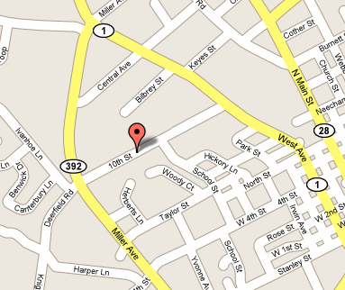  7  map  a visual representation  of an area  Example: Maps are representations of places, but not the actual places themselves.  (SS060103)
8  globe  a spherical, or ball-shaped, model of the entire planet    Example: A globe shows the true relative size and shape of the continents.  (SS060103) | 9  Global Positioning  System (GPS)  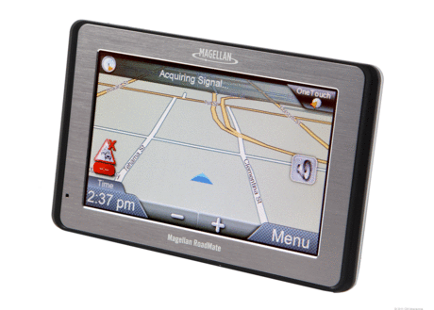  a system that uses a network of earth-orbiting satellites to pinpoint absolute location  Example: Many people use a GPS device in their cars.  (SS060103)
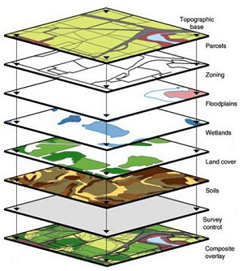
10
Global Information Systems (GIS)

computer or Internet-based mapping technology

Example: The traffic update on the evening news uses geographic information systems.

(SS060103)

Geographic Inquiry

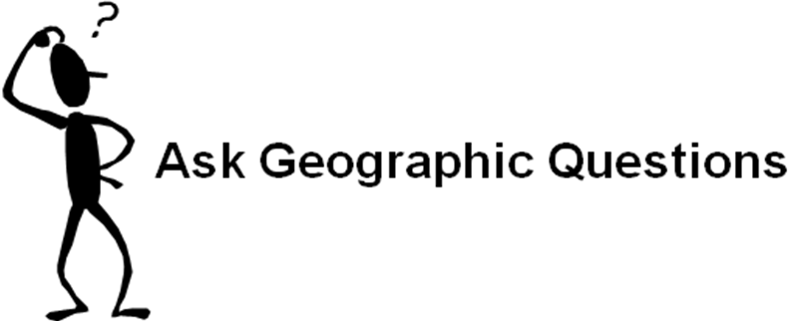


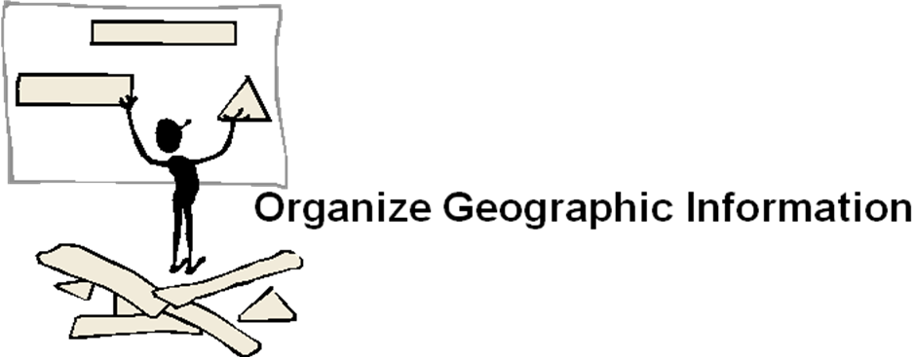



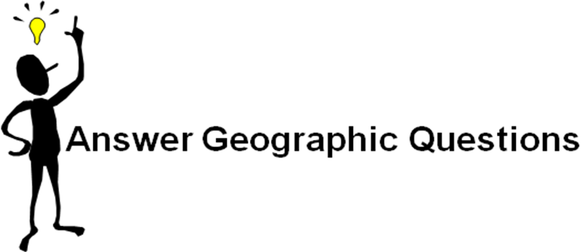
Different Representations of the Earth

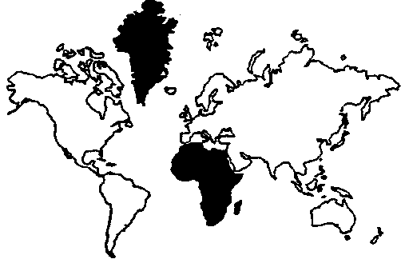
Mercator Projection

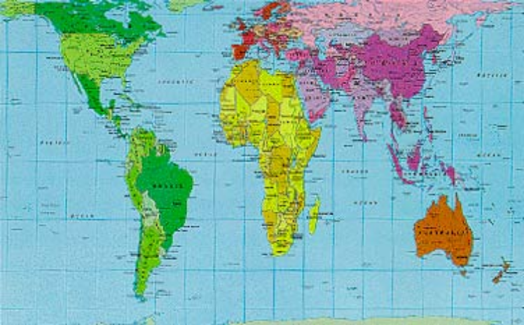
Peters Projection

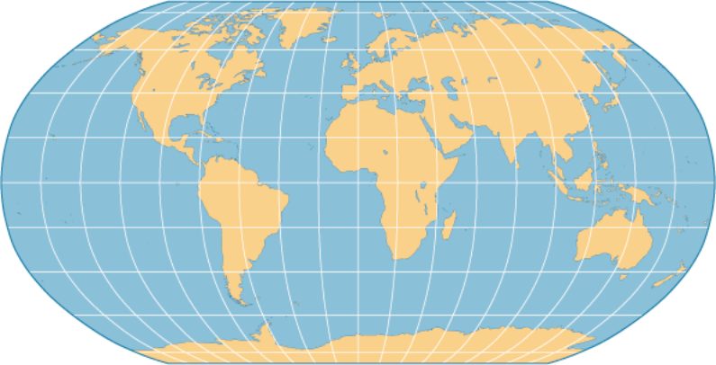
Robinson Projection

Satellite Images
1
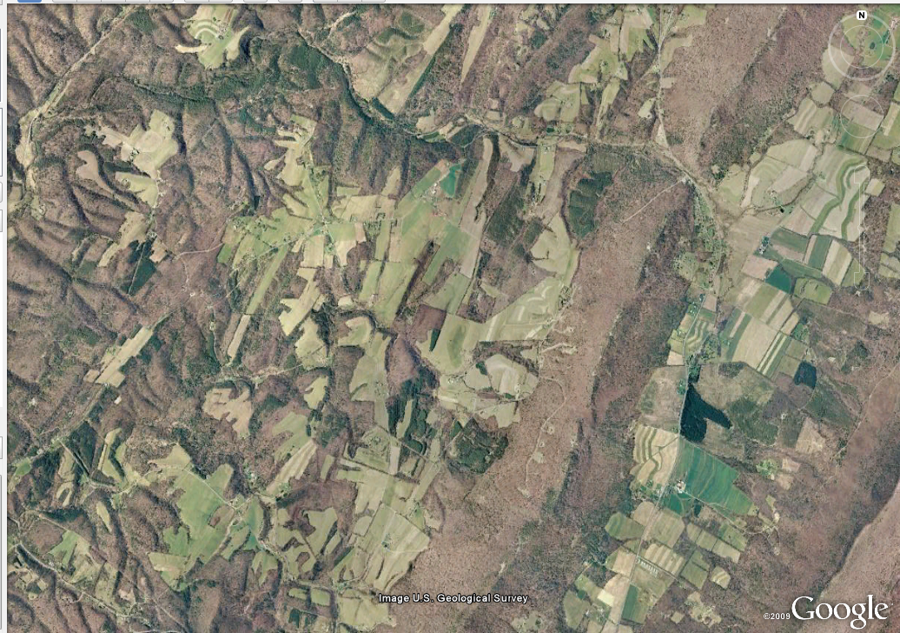

2
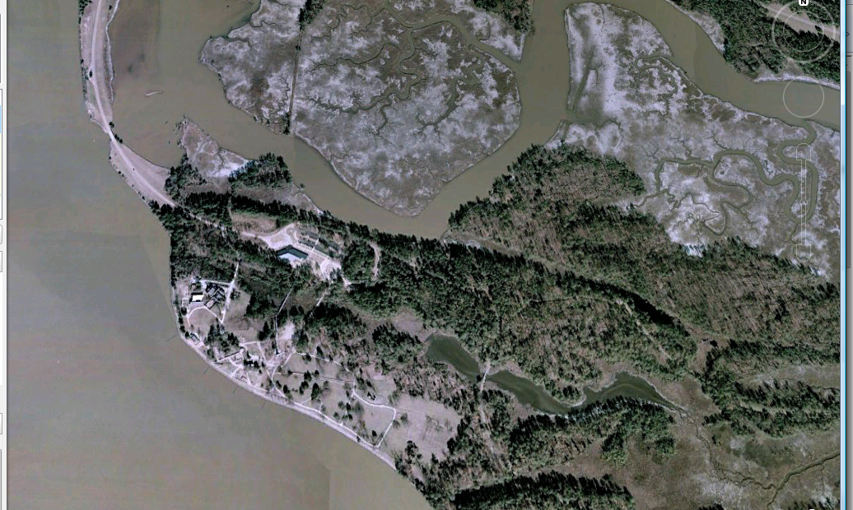
3
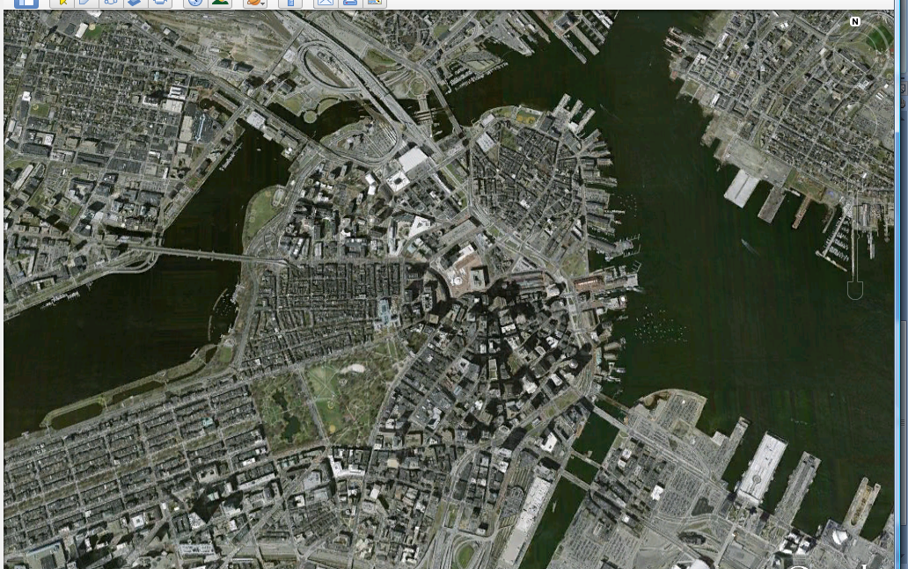

4
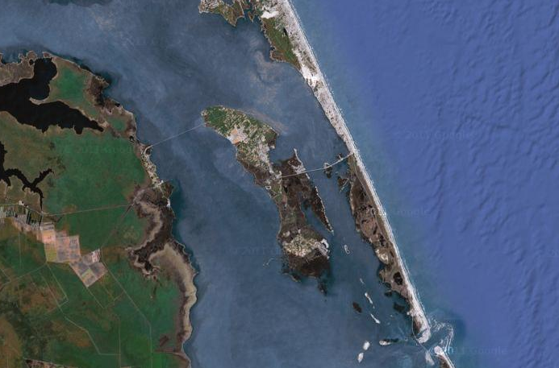
5
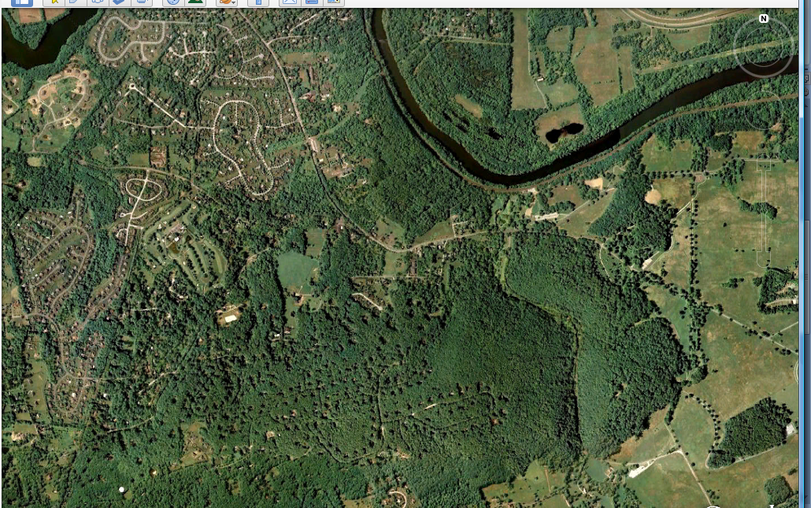

6
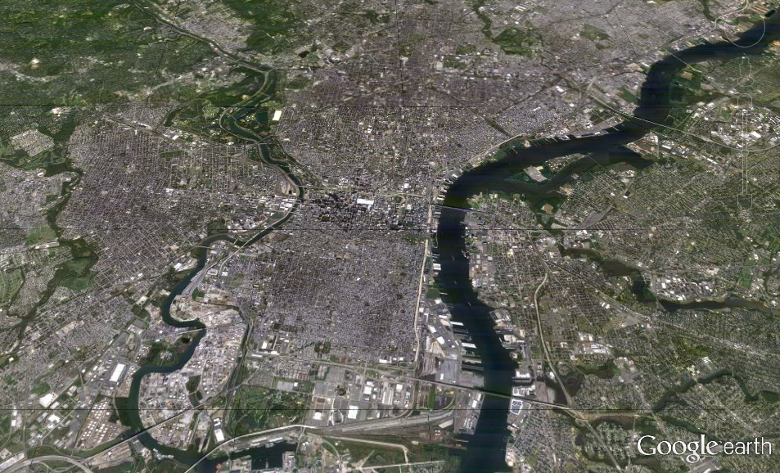
Interpreting Satellite Images

# | Describe the place | Identify the place  Guess #1 | Identify the place guess #2
1
2
3
4
5
6
Interpreting Satellite Images – Sample Answers

# | Describe the place | Identify the place  Guess #1 | Identify the place guess #2
1 | An area that has some farms but no cities. It also has rocks or sand. | Answers will vary | Appalachian Mountains
2 | A piece of land that might be a peninsula. It has a road connecting it to something else. There are trees in some areas and what looks like small roads. Parts of it look like a dried-up area. | Answers will vary | Jamestown
3 | A big city near water with lots of docks and buildings. It has several bridges and a lot of straight roads. It looks like there is a large downtown area in the center. | Answers will vary | Boston
4 | Two narrow islands off the mainland. The mainland has a lot of green which might be fields. It looks like there is a bridge connecting the two islands and a bridge connecting one with the mainland. | Answers will vary | Roanoke Island
5 | A green park-like area with a lot of houses around it that look like subdivisions. There’s a river running alongside it. | Answers will vary | Valley Forge
6 | An urban area with two rivers, one which is bigger than the other. There are bridges and docks. At the outer edges is rural area. It looks like a big metropolitan area. | Answers will vary | Philadelphia
What is GIS?

A geographic information system (GIS) integrates hardware, software, and data for capturing, managing, analyzing, and displaying all forms of geographically referenced information.
GIS allows us to view, understand, question, interpret, and visualize data in many ways that reveal relationships, patterns, and trends in the form of maps, globes, reports, and charts.
A GIS helps you answer questions and solve problems by looking at your data in a way that is quickly understood and easily shared.
GIS technology can be integrated into any enterprise information system framework.

GIS benefits organizations of all sizes and in almost every industry. There is a growing awareness of the economic and strategic value of GIS. The benefits of GIS generally fall into five basic categories:
- Cost Savings and Increased Efficiency
- Better Decision Making
- Improved Communication
- Better Recordkeeping
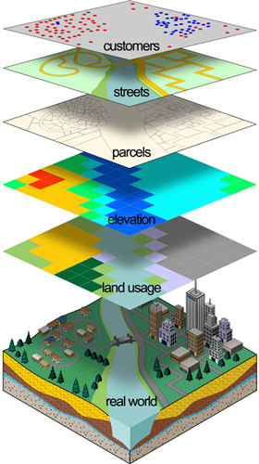
- Managing Geographically

What Can You Do with GIS?

GIS gives us a new way to look at the world around us. With GIS you can:
- Map Where Things Are
- Map Quantities
- Map Densities
- Find What's Inside
- Find What's Nearby
- Map Change

Source: What is GIS? 8 July 2012. http://www.esri.com/what-is-gis/index.html
Teacher Reference Sheet: GIS
From the US Geological Survey
http://egsc.usgs.gov/isb/pubs/gis_poster/#what

Geographic information system (GIS) technology can be used for scientific investigations, resource management, and development planning. For example, a GIS might allow emergency planners to easily calculate emergency response times in the event of a natural disaster, or a GIS might be used to find wetlands that need protection from pollution.

What is a GIS?
A GIS is a computer system capable of capturing, storing, analyzing, and displaying geographically referenced information; that is, data identified according to location. Practitioners also define a GIS as including the procedures, operating personnel, and spatial data that go into the system.

How does a GIS work?

Relating information from different sources
The power of a GIS comes from the ability to relate different information in a spatial context and to reach a conclusion about this relationship. Most of the information we have about our world contains a location reference, placing that information at some point on the globe. When rainfall information is collected, it is important to know where the rainfall is located. This is done by using a location reference system, such as longitude and latitude, and perhaps elevation. Comparing the rainfall information with other information, such as the location of marshes across the landscape, may show that certain marshes receive little rainfall. This fact may indicate that these marshes are likely to dry up, and this inference can help us make the most appropriate decisions about how humans should interact with the marsh. A GIS, therefore, can reveal important new information that leads to better decision making.
Many computer databases that can be directly entered into a GIS are being produced by Federal, State, tribal, and local governments, private companies, academia, and nonprofit organizations. Different kinds of data in map form can be entered into a GIS (figs. 1a, 1b, 1c, 1d, 1e, 1f, and 2). A GIS can also convert existing digital information, which may not yet be in map form, into forms it can recognize and use. For example, digital satellite images can be analyzed to produce a map of digital information about land use and land cover (figs. 3 and 4). Likewise, census or hydrologic tabular data can be converted to a maplike form and serve as layers of thematic information in a GIS (figs. 5 and 6).
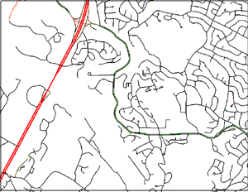  Figure 1a. U.S. Geological Survey (USGS) digital line graph (DLG) data of roads. | 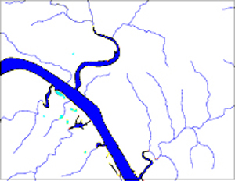  Figure 1b. USGS DLG of rivers.
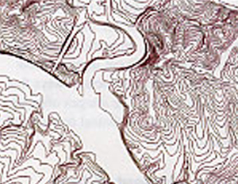  Figure 1c. USGS DLG of contour lines (hypsography). | 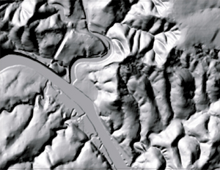  Figure 1d. USGS digital elevation (DEM).
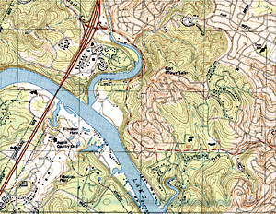  Figure 1e. USGS scanned, rectified topographic map called a digital raster graphic (DRG). | 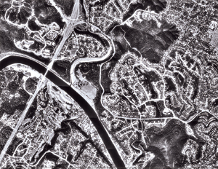  Figure 1f. USGS digital orthophoto quadrangle (DOQ).
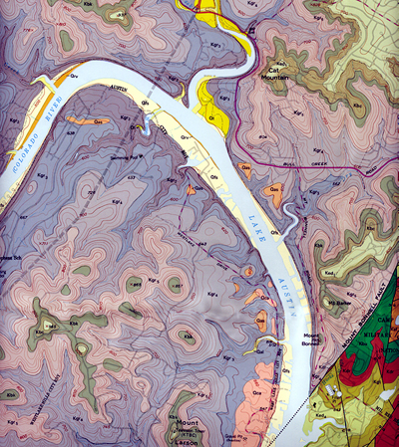
Figure 2. USGS geologic map.

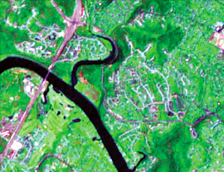  Figure 3. Landsat 7 satellite image from which land cover information can be derived. | 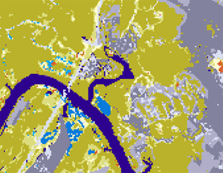  Figure 4. Satellite image data in figure 3 have been analyzed to indicate classes of land uses and cover.
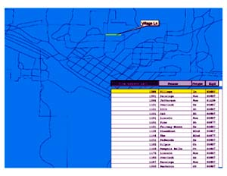  Figure 5. Part of a census data file containing address information. | 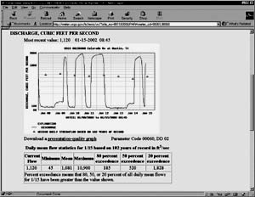  Figure 6. Part of a hydrologic data report indicating the discharge and amount of river flow recorded by a particular streamgage that has a known location.

Data Capture
Data capture—putting the information into the system—involves identifying the objects on the map, their absolute location on the Earth's surface, and their spatial relationships. Software tools that automatically extract features from satellite images or aerial photographs are gradually replacing what has traditionally been a time-consuming capture process. Objects are identified in a series of attribute tables—the "information" part of a GIS. Spatial relationships, such as whether features intersect or whether they are adjacent, are the key to all GIS-based analysis.

Data integration
A GIS makes it possible to link, or integrate, information that is difficult to associate through any other means. Thus, a GIS can use combinations of mapped variables to build and analyze new variables (fig. 7).
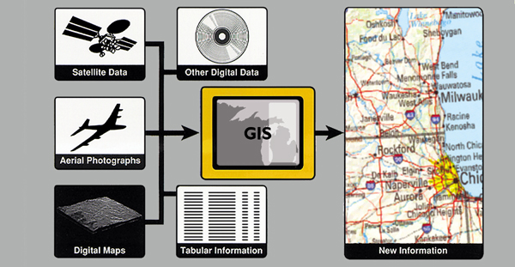
Figure 7. Data integration is the linking of information in different forms through a GIS.
For example, using GIS technology, it is possible to combine agricultural records with hydrography data to determine which streams will carry certain levels of fertilizer runoff. Agricultural records can indicate how much pesticide has been applied to a parcel of land. By locating these parcels and intersecting them with streams, the GIS can be used to predict the amount of nutrient runoff in each stream. Then as streams converge, the total loads can be calculated downstream where the stream enters a lake.

Projection and registration
A property ownership map might be at a different scale than a soils map. Map information in a GIS must be manipulated so that it registers, or fits, with information gathered from other maps. Before the digital data can be analyzed, they may have to undergo other manipulations—projection conversions, for example—that integrate them into a GIS.
Projection is a fundamental component of mapmaking. A projection is a mathematical means of transferring information from the Earth's three-dimensional, curved surface to a two-dimensional medium—paper or a computer screen. Different projections are used for different types of maps because each projection is particularly appropriate for certain uses. For example, a projection that accurately represents the shapes of the continents will distort their relative sizes.
Since much of the information in a GIS comes from existing maps, a GIS uses the processing power of the computer to transform digital information, gathered from sources with different projections, to a common projection (figs. 8a and b).
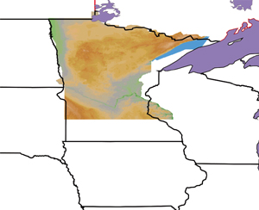  Figure 8a. An elevation image classified from a satellite image of Minnesota exists in a different scale and projection than the lines on the digital file of the State and province boundaries. | 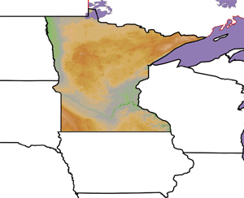  Figure 8b. The elevation image has been reprojected to match the projection and scale of the State and province boundaries.

What is Special about GIS?
The way maps and other data have been stored or filed as layers of information in a GIS makes it possible to perform complex analyses.
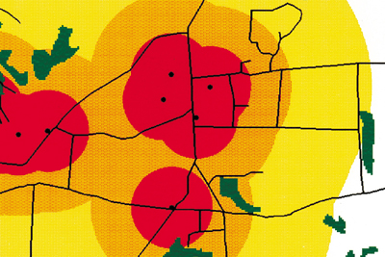
Figure 9. Sources of pollution are represented as points. The colored circles show distance from pollution sources and the wetlands are in dark green.

Topological modeling
Have there ever been gas stations or factories that operated next to the swamp? Were any of these uphill from and within 2 miles of the swamp? A GIS can recognize and analyze the spatial relationships among mapped phenomena. Conditions of adjacency (what is next to what), containment (what is enclosed by what), and proximity (how close something is to something else) can be determined with a GIS (fig. 9).
Networks
When nutrients from farmland are running off into streams, it is important to know in which direction the streams flow and which streams empty into other streams. This is done by using a linear network. It allows the computer to determine how the nutrients are transported downstream. Additional information on water volume and speed throughout the spatial network can help the GIS determine how long it will take the nutrients to travel downstream (figs. 10a and b).
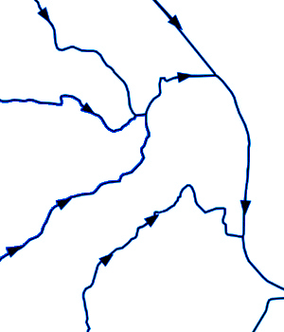  Figure 10a. A GIS can simulate the movement of materials along a network of lines. These illustrations show the route of pollutants through a stream system. Flow directions are indicated by arrows. | 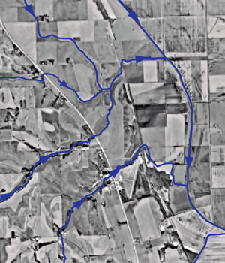  Figure 10b. Flow superimposed on a digital orthophoquad of the area.

Overlay
Using maps of wetlands, slopes, streams, land use, and soils, the GIS might produce a new map layer or overlay that ranks the wetlands according to their relative sensitivity to damage from nutrient runoff.

Data output
A critical component of a GIS is its ability to produce graphics on the screen or on paper to convey the results of analyses to the people who make decisions about resources. Wall maps, Internet-ready maps, interactive maps, and other graphics can be generated, allowing the decision makers to visualize and thereby understand the results of analyses or simulations of potential events (fig. 20).

Framework for cooperation
The use of a GIS can encourage cooperation and communication among the organizations involved in environmental protection, planning, and resource management. The collection of data for a GIS is costly. Data collection can require very specialized computer equipment and technical expertise.
Standard data formats ease the exchange of digital information among users of different systems. Standardization helps to stretch data collection funds further by allowing data sharing, and, in many cases, gives users access to data that they could not otherwise collect for economic or technical reasons. Organizations such as the University Consortium for Geographic Information Science (www.ucgis.org) and the Federal Geographic Data Committee (www.fgdc.gov) seek to encourage standardization efforts.

Emergency response planning
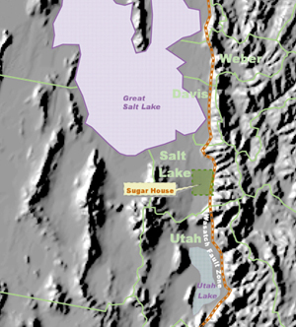
The Wasatch Fault zone runs through Salt Lake City along the foot of the Wasatch Mountains in north-central Utah (fig. 11).

Figure 11. Map of the area surrounding the USGS Sugar House 7.5-minute quadrangle, Salt lake City, Utah, showing the location of the Wasatch Fault zone.
A GIS was used to combine road network and earth science information to analyze the effect of an earthquake on the response time of fire and rescue squads. The area covered by the USGS Sugar House 7.5-minute topographic quadrangle map was selected for the study because it includes both undeveloped areas in the mountains and a part of Salt Lake City. Detailed earth science information was available for the entire region.
The road network from a USGS digital line graph includes information on the types of roads, which range from rough trails to divided highways (fig. 12). The locations of fire stations were plotted on the road network. A GIS function called network analysis was used to calculate the time necessary for emergency vehicles to travel from the fire stations to different areas of the city. The network analysis function considers two elements: (1) distance from the fire station, and (2) speed of travel based on the type of road. The analysis shows that under normal conditions, most of the area within the city will be served in less than 7 minutes and 30 seconds because of the distribution and density of fire stations and the continuous network of roads.
The accompanying illustration (fig. 13) depicts the blockage of the road network that would result from an earthquake, assuming that any road crossing the fault trace would become impassable. The primary effect on emergency response time would occur in neighborhoods west of the fault trace, where travel times from the fire stations would be noticeably lengthened.
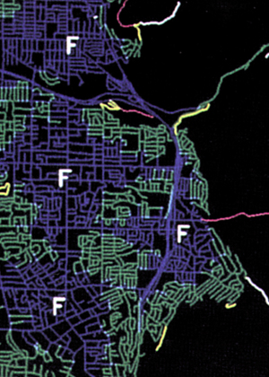  Figure 12. Before faulting. Road network of area covered by the Sugar House quadrangle plotted from USGS digital line graph data, indicating the locations of fire stations and travel times of emergency vehicles. Areas in blue can receive service within 2½minutes, area in green within 5 minutes, areas in yellow within 7½ minutes, and areas in magenta within 10 minutes. Areas in white cannot receive service within 10 minutes. | 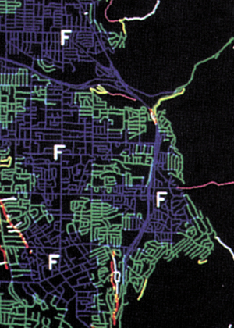  Figure 13. After faulting, initial model. Network analysis in a GIS produces a map of travel times from the stations after faulting. The fault is in red. Emergency response times have increased for areas west of the fault.
The Salt Lake City area lies on lake sediments of varying thicknesses. These sediments range from clay to sand and gravel, and most are water-saturated. In an earthquake, these materials may momentarily lose their ability to support surface structures, including roads. The potential for this phenomenon, known as liquefaction, is shown in a composite map portraying the inferred relative stability of the land surface during an earthquake. Areas near the fault and underlain by thick, loosely consolidated, water-saturated sediments will suffer the most intense surface motion during an earthquake (fig. 23). Areas on the mountain front with thin surface sediments will experience less additional ground acceleration. The map of liquefaction potential was combined with the road network analysis to show the additional effect of liquefaction on response times.
The final map shows that areas near the fault, as well as those underlain by thick, water-saturated sediments, are subject to more road disruptions and slower emergency response than are other areas of the city (fig. 24).
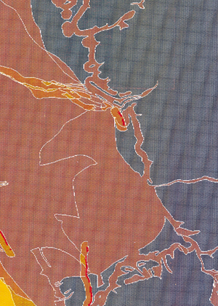  Figure 23. Map of potential ground l liquefaction during an earthquake. The least stable areas are shown by yellows and oranges, the most stable by grays and browns. | 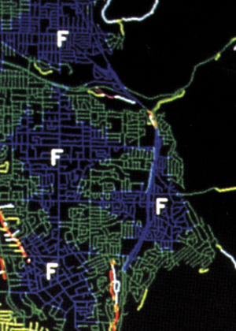  Figure 24. After faulting, final model. A map showing the effect of an earthquake on emergency travel times is reduced by combining the liquefaction potential information from figure 23 with the network analysis from figure 22.

The future of GIS
Environmental studies, geography, geology, planning, business marketing, and other disciplines have benefitted from GIS tools and methods. Together with cartography, remote sensing, global positioning systems, photogrammetry, and geography, the GIS has evolved into a discipline with its own research base known as geographic information sciences. An active GIS market has resulted in lower costs and continual improvements in GIS hardware, software, and data. These developments will lead to a much wider application of the technology used by government, business, and industry.
GIS and related technology will help analyze large datasets, allowing a better understanding of terrestrial processes and human activities to improve economic vitality and environmental quality.

For more information
Good places to learn more about GIS technology and methods include the geography department of your local university, the GIS site at www.gis.com, your county planning department, your state department of natural resources, or a USGS Earth Science Information Center (ESIC). To locate your nearest ESIC, call 1-888-ASK-USGS, visit ASK-USGS web site, or visit www.usgs.gov.

