Reconstruction Amendments

13th Amendment (1865)

Neither slavery nor involuntary servitude, except as punishment for crime whereof the party shall have been duly convicted, shall exist within the United States, or any place subject to their jurisdiction. Congress shall have power to enforce this article by appropriate legislation.

14th Amendment (1868)

Section 1: All persons born or naturalized in the United States, and subject to the jurisdiction thereof, are citizens of the United States and of the state wherein they reside. No state shall make or enforce any law which shall abridge the privileges or immunities of citizens of the United States; nor shall any state deprive any person of life, liberty, or property without due process of law; nor deny to any person within its jurisdiction the equal protection of the laws.

15th Amendment (1870)

The right of citizens of the United States to vote shall not be denied or abridged by the United States or by any state on account of race, color, or previous condition of servitude. The Congress shall have power to enforce this article by appropriate legislation.

Examples of Black Codes

From the 1880s into the 1960s, a majority of American states enforced segregation through Black Codes. The most common types of laws forbade intermarriage and ordered business owners and public institutions to keep their black and white clientele separated. Below is a sampling of laws from various states:

Nurses No person or corporation shall require any white female nurse to nurse in wards or rooms in hospitals, either public or private, in which negro men are placed. Alabama
Buses All passenger stations in this state operated by any motor transportation company shall have separate waiting rooms or space and separate ticket windows for the white and colored races. Alabama
Restaurants It shall be unlawful to conduct a restaurant or other place for the serving of food in the city, at which white and colored people are served in the same room, unless such white and colored persons are effectually separated by a solid partition extending from the floor upward to a distance of seven feet or higher, and unless a separate entrance from the street is provided for each compartment. Alabama
Toilet Facilities, Male Every employer of white or negro males shall provide for such white or negro males reasonably accessible and separate toilet facilities. Alabama
Intermarriage The marriage of a person of Caucasian blood with a Negro, Mongolian, Malay, or Hindu shall be null and void. Arizona
Intermarriage All marriages between a white person and a negro, or between a white person and a person of negro descent to the fourth generation inclusive, are hereby forever prohibited. Florida
Intermarriage All marriages between a white person and a negro, or between a white person and a person of negro descent, to the third generation, inclusive, or between a white person and a member of the Malay race; or between the negro and a member of the Malay race; or between a person of Negro descent, to the third generation, inclusive, and a member of the Malay race, are forever prohibited, and shall be void. Maryland
Intermarriage All marriages of white persons with Negroes, Mulattos, Mongolians, or Malaya hereafter contracted in the State of Wyoming are and shall be illegal and void. Wyoming
Cohabitation Any negro man and white woman, or any white man and negro woman, who are not married to each other, who shall habitually live in and occupy in the nighttime the same room shall each be punished by imprisonment not exceeding twelve (12) months, or by fine not exceeding five hundred ($500.00) dollars. Florida
Education The schools for white children and the schools for negro children shall be conducted separately. Florida
Mental Hospitals The Board of Control shall see that proper and distinct apartments are arranged for said patients, so that in no case shall Negroes and white persons be together. Georgia
Barbers No colored barber shall serve as a barber [to] white women or girls. Georgia
Burial The officer in charge shall not bury, or allow to be buried, any colored persons upon ground set apart or used for the burial of white persons. Georgia
Amateur Baseball It shall be unlawful for any amateur white baseball team to play baseball on any vacant lot or baseball diamond within two blocks of a playground devoted to the Negro race, and it shall be unlawful for any amateur colored baseball team to play baseball in any vacant lot or baseball diamond within two blocks of any playground devoted to the white race. Georgia
Parks It shall be unlawful for colored people to frequent any park owned or maintained by the city for the benefit, use and enjoyment of white persons...and unlawful for any white person to frequent any park owned or maintained by the city for the use and benefit of colored persons. Georgia
Wine and Beer All persons licensed to conduct the business of selling beer or wine...shall serve either white people exclusively or colored people exclusively and shall not sell to the two races within the same room at any time. Georgia
Reform Schools The children of white and colored races committed to the houses of reform shall be kept entirely separate from each other. Kentucky
Housing Any person...who shall rent any part of any such building to a negro person or a negro family when such building is already in whole or in part in occupancy by a white person or white family, or vice versa when the building is in occupancy by a negro person or negro family, shall be guilty of a misdemeanor and on conviction thereof shall be punished by a fine of not less than twenty-five ($25.00) nor more than one hundred ($100.00) dollars or be imprisoned not less than 10, or more than 60 days, or both such fine and imprisonment in the discretion of the court. Louisiana
The Blind The board of trustees shall...maintain a separate building...on separate ground for the admission, care, instruction, and support of all blind persons of the colored or black race. Louisiana
Railroads All railroad companies and corporations, and all persons running or operating cars or coaches by steam on any railroad line or track in the State of Maryland, for the transportation of passengers, are hereby required to provide separate cars or coaches for the travel and transportation of the white and colored passengers. Maryland
Promotion of Equality Any person...who shall be guilty of printing, publishing or circulating printed, typewritten or written matter urging or presenting for public acceptance or general information, arguments or suggestions in favor of social equality or of intermarriage between whites and negroes, shall be guilty of a misdemeanor and subject to fine or not exceeding five hundred (500.00) dollars or imprisonment not exceeding six (6) months or both. Mississippi
Hospital Entrances There shall be maintained by the governing authorities of every hospital maintained by the state for treatment of white and colored patients separate entrances for white and colored patients and visitors, and such entrances shall be used by the race only for which they are prepared. Mississippi
Prisons The warden shall see that the white convicts shall have separate apartments for both eating and sleeping from the negro convicts. Mississippi
Education Separate rooms [shall] be provided for the teaching of pupils of African descent, and [when] said rooms are so provided, such pupils may not be admitted to the school rooms occupied and used by pupils of Caucasian or other descent. New Mexico
Textbooks Books shall not be interchangeable between the white and colored schools, but shall continue to be used by the race first using them. North Carolina
Libraries The state librarian is directed to fit up and maintain a separate place for the use of the colored people who may come to the library for the purpose of reading books or periodicals. North Carolina
Militia The white and colored militia shall be separately enrolled, and shall never be compelled to serve in the same organization. No organization of colored troops shall be permitted where white troops are available, and while white permitted to be organized, colored troops shall be under the command of white officers. North Carolina
Teaching Any instructor who shall teach in any school, college or institution where members of the white and colored race are received and enrolled as pupils for instruction shall be deemed guilty of a misdemeanor, and upon conviction thereof, shall be fined in any sum not less than ten dollars ($10.00) nor more than fifty dollars ($50.00) for each offense. Oklahoma
Telephone Booths The Corporation Commission is hereby vested with power and authority to require telephone companies...to maintain separate booths for white and colored patrons when there is a demand for such separate booths. Oklahoma
Lunch Counters No persons, firms, or corporations, who or which furnish meals to passengers at station restaurants or station eating houses, in times limited by common carriers of said passengers, shall furnish said meals to white and colored passengers in the same room, or at the same table, or at the same counter. South Carolina
Child Custody It shall be unlawful for any parent, relative, or other white person in this State, having the control or custody of any white child, by right of guardianship, natural or acquired, or otherwise, to dispose of, give or surrender such white child permanently into the custody, control, maintenance, or support, of a negro. South Carolina
Education [The County Board of Education] shall provide schools of two kinds; those for white children and those for colored children. Texas
Theaters Every person...operating...any public hall, theatre, opera house, motion picture show or any place of public entertainment or public assemblage which is attended by both white and colored persons, shall separate the white race and the colored race and shall set apart and designate...certain seats therein to be occupied by white persons and a portion thereof, or certain seats therein, to be occupied by colored persons. Virginia

Source: “Examples of Jim Crow Laws.’’ Race, Racism, and the Law. University of Dayton. 1993. 14 March 2011 <http://academic.udayton.edu/Race/02rights/jcrow02.htm>.

Jim Crow Etiquette
The following norms show how inclusive and pervasive Jim Crow was:
- A Black male could not offer his hand (to shake hands) with a White male because it implied being socially equal. Obviously, a Black male could not offer his hand or any other part of his body to a White woman, because he risked being accused of rape.
- Blacks and Whites were not supposed to eat together. If they did eat together, Whites were to be served first, and some sort of partition was to be placed between them.
- Under no circumstance was a Black male to offer to light the cigarette of a White female -- that gesture implied intimacy.
- Blacks were not allowed to show public affection toward one another in public, especially kissing, because it offended Whites.
- Jim Crow etiquette prescribed that Blacks were introduced to Whites, never Whites to Blacks. For example: "Mr. Peters (the White person), this is Charlie (the Black person), that I spoke to you about."
- Whites did not use courtesy titles of respect when referring to Blacks, for example, Mr., Mrs., Miss., Sir, or Ma'am. Instead, Blacks were called by their first names. Blacks had to use courtesy titles when referring to Whites, and were not allowed to call them by their first names.
- If a Black person rode in a car driven by a White person, the Black person sat in the back seat, or the back of a truck.
- White motorists had the right-of-way at all intersections.

Source: “What was Jim Crow?” Jim Crow. Ferris State University. 14 March 2011 <http://www.ferris.edu/jimcrow/what.htm>.
Plessy v. Ferguson

In 1890, Louisiana passed a statute called the Separate Car Act, which stated "that all railway companies carrying passengers in their coaches in this state, shall provide equal but separate accommodations for the white, and colored races, by providing two or more passenger coaches for each passenger train, or by dividing the passenger coaches by a partition so as to secure separate accommodations. . . . " The penalty for sitting in the wrong compartment was a fine of $25 or 20 days in jail.

On June 7, 1892, Homer Plessy purchased a first-class passage from New Orleans to Covington, Louisiana and sat in the railroad car designated for whites only. The railroad officials, following through on the arrangement, arrested Plessy and charged him with violating the Separate Car Act.

In court, Plessy argued that the Separate Car Act violated the Thirteenth and Fourteenth Amendments to the Constitution.

Thirteenth Amendment
Section 1. Neither slavery nor involuntary servitude, except as a punishment for crime whereof the party shall have been duly convicted, shall exist within the United States, or any place subject to their jurisdiction.

Fourteenth Amendment
Section 1. All persons born or naturalized in the United States and subject to the jurisdiction thereof are citizens of the United States and of the State wherein they reside. No State shall make or enforce any law which shall abridge the privileges or immunities of citizens of the United States; nor shall any State deprive any person of life, liberty, or property, without due process of law; nor deny to any person within its jurisdiction the equal protection of the laws.

1a. If you were Plessy’s lawyer, how would you justify your claim that the “Separate Car Act” violates the Thirteenth and Fourteenth amendments?

1b. If you were the representing the state of Louisiana, how would you justify your claim that the “Separate Car Act” did not violate the Thirteenth or Fourteenth Amendments?

The Impact of the Case: Separate But Equal

Although not specifically written in the decision, Plessy set the precedent that "separate" facilities for blacks and whites were constitutional as long as they were "equal." The "separate but equal" doctrine was quickly extended to cover many areas of public life, such as restaurants, theaters, restrooms, and public schools.

The Supreme Court of the United States determined that if legislation makes distinctions based on race, but does not deprive anyone of rights or privileges, it is constitutional. The Court seemed to believe that the common practice of separation was an inconvenience, not something that abridged the rights of African Americans. The Court also presumed that legislation was powerless to do away with racial instincts or to abolish distinctions based on physical differences.

Directions
Think about the following situations. Each situation offers separate accommodations for the people involved. Are those accommodations equal? Do you think the Supreme Court of the United States considered all possible situations when they rendered their decision in Plessy v. Ferguson? Discuss each situation with your classmates.

- A black woman is thirsty, so she walks over to the water fountains. There is one fountain for blacks and one for whites. The black woman uses the fountain for whites because the other one is out of order.
- A black man has been traveling for many hours. He stops at a diner to eat and use the restroom. This diner only serves whites. In order to eat, the black man must travel another two hours to another diner that serves blacks. The black man cannot wait two hours to use the restroom, so he uses the diner's restroom despite the posted signs.
- A white man is not allowed to have his colored attendant with him in the same train coach even though the white man's health condition requires constant supervision. The colored attendant ignores the rules and sits beside his employer in the coach for white passengers.
- A black seven-year-old girl must walk two miles to the nearest school for blacks even though there is a school two blocks away. The school two blocks away is only for white students. The girl's parents worry about their daughter walking such a long distance to and from school everyday.

Source: “The Impact of the Case: Separate But Equal.” Landmark Cases of the U.S. Supreme Court. Street Law and the Supreme Court Historical Society. 2010. 14 March 2011 <http://www.streetlaw.org//en/Page.Landmark.Plessy.activities.impact.aspx>.
Civil Rights during World War II
The Civil Rights Movement as we know it today did not begin in earnest until the advent of World War II. The war brought into focus the contradictions between our ideals of freedom and the dignity of all humans with the reality of Jim Crow. Hitler's belief in the supremacy of the Aryan race and the consequences of his hatred towards the Jews and other minority groups inferior brought into question the validity of white racial supremacy in America.
The basic American democratic values of freedom and liberty were denied to African Americans during Jim Crow (1896-1954). Along with the cold war ideological struggle (tyranny versus freedom), the United States government became more receptive to African American demands for Civil Rights. Due to the changing political climate, African Americans’ struggle for civil rights became more urgent and successful.
As Hitler was taking over Europe, America was mobilizing for the impending war. Now more than ever the United States needed a united nation, one in which all of its people were willing to make sacrifices in the name of freedom and democracy. President Roosevelt expanded the meaning of freedom by proclaiming the "four freedoms": freedom of speech, freedom of religion, freedom from want, and freedom from fear as fundamental goals of the United States. While Roosevelt's concept of freedom was in line with America’s core values, some have argued that it was contradicted by the harsh realities of Jim Crow. Under Jim Crow laws, African Americans were segregated from the rest of society. African Americans were forced to live in separate areas, go to separate inferior schools, sit in the back of buses, live through the fear of white violence, and were denied suffrage by the poll tax. This contradiction between the ideology of the United States and the reality of Jim Crow divided America at a time when it needed all of the nation’s resources.
During the mobilization and actual fighting of World War II, African Americans called for the integration of the National Defense Industries and the armed services. The first method used was that of black lobbying in Congress and the White House through letter writing and personal pleas. This form of quiet pressure did little to change the status quo. With the backing of the NAACP (National Association for the Advancement of Colored People), civil rights organizations were able to bring considerable pressure on the government. In pushing for more integration in National Defense employment and the armed forces, these groups threatened to march on Washington with over ten thousand blacks. The march was to only include African Americans out of fear that it would be taken over by white liberal communists. Moreover, if blacks were the only ones in the march then it would show that African Americans could organize and mobilize people by themselves.
A. Phillip Randolph, the organizer of the march, was able to mobilize enough people to exert political pressure on politicians in Washington. President Franklin D. Roosevelt was concerned that the march would cause the country to divide more along racial lines than it already was at a time when unity was needed in the war effort. As a result, on June 25, 1941 President Roosevelt signed Executive Order 8802. The order mandated that "there shall be no discrimination in the employment of workers in defense industries or government because of race, creed color, or national origin." Furthermore it was “the duty of the employers and labor organizations …to provide for the full and equitable participation of all workers in defense industries." The order also established the Fair Employment Practices Committee (FEPC), whose job it was to investigate complaints of discrimination in the defense industries and to take the necessary steps to resolve the problem. Although it was supposed to stop discrimination in the defense industry, the FEPC lacked any real enforcement power. Yet, for the first time since the Civil Rights Act of 1875, the federal government took concrete action to protect the rights of black Americans.
Not only did African Americans become more militant during the war, but white Americans became more accepting of African Americans especially those who served with blacks in the service. In a poll that measured the "Attitudes of White Soldiers toward Serving with Black Units,” about 33 percent of white officers and 35 percent of Non-Commissioned Officers (NCOs) felt favorable in initial feelings about serving with black units. After serving with black units, 77 percent of officers and 77 percent of NCOs felt more favorable in serving with black units.
Questions

- What techniques did African-Americans use to promote Civil Rights during the war?

- What successes did Civil Rights activists achieve during the war?

- What obstacles remained despite the successes?

- What motivated some white Americans to be more accepting of African-Americans?

Adapted from Civil Rights During World War II. Political Science Department, Providence College. 14 March 2011 <http://www.providence.edu/polisci/students/civil_rights/crwwii.htm>.
Reference Guide for Notes on “Civil Rights during WWII”

Topics | From the Reading
Techniques Used | - Lobbying (i.e., letter writing and personal appeals to Washington)  - Threat of organized protest  - Used war propaganda and American values to fight for freedom at home  - Reasoned discourse
Success Achieved | - Passage of Executive Order 8802 banned discrimination in the employment of workers in defense industries or government  - Creation of Fair Employment Practices Committee (FEPC) to investigate complaints of discrimination in the defense industries and to take the necessary steps to resolve the problem  - Federal government took concrete action to protect the rights of African Americans  - White Americans became more accepting of African-Americans
Remaining Obstacles | - Institutionalized segregation still in effect  - Widespread racist attitudes remained  - Discrimination against African Americans remained
Motivations behind White Acceptance | - Service with African Americans in the military  - Desire to live up to American’s core values
Timed Reading (ACT Prep)
1

5

10

15

20

25

30

35

40

Cold War Civil Rights: Race and the Image of American Democracy is the first comprehensive analysis of how Cold War foreign relations influenced U.S. civil rights policy from World War II until the mid-sixties. By considering the Cold War and the Civil Rights Movement together, Dudziak argues that race was a national security issue, central to ideological conflicts over American democracy. Her argument helps explain a seeming contradiction. Why did the federal government begin to support civil rights within a largely hostile environment? After all, southerners held considerable power in Congress and white southern voters could make or break a presidential election. Turning our focus toward the international arena, Dudziak argues that the problem of race attracted so much foreign attention in the early Cold War that it threatened to undermine U.S. claims to the superiority of democracy over communism. Organized around the civil rights conflicts that provoked the most international uproar such as Little Rock and Birmingham, the book vividly shows why race refused to disappear from any presidential agenda from Truman to Johnson.

One of Dudziak's strongest arguments is that the U.S. government attempted to safeguard America's image and counter Soviet propaganda by constructing a story of the nation's past that acknowledged racial discrimination but presented American democracy itself as the only viable pathway forward. Early in the Cold War, Truman officials decided that since they could not hide the U.S.'s legacy of slavery and discrimination, they would incorporate it into a story of redemption, presenting democracy as "the vehicle for national reconciliation." The logic of this "narrative of race and democracy," as Dudziak calls it, required U.S. presidents to pursue civil rights reforms. Drawing on court decisions and legal briefs, she details U.S. arguments that national security interests were at stake in these decisions.

Likewise, Dudziak argues, John F. Kennedy found it impossible to pursue American strategic interests abroad without promoting civil rights at home, especially when it came to Africa, where seventeen nations achieved independence between January and November 1960. Keenly attuned to Cold War foreign relations but initially far less committed to civil rights, Kennedy shifted direction midstream by calling for major civil rights legislation after Bull Connors's televised fire hosing of demonstrators in Birmingham prompted international condemnation. Dudziak makes creative use of correspondence and clippings from U.S. embassies to show how closely the State Department monitored foreign opinion. The analysis of Kennedy and Africa is especially strong.

Dudziak's chapter on the Johnson administration is particularly provocative. By 1965, she argues, the race and democracy narrative had largely achieved its goals, once the 1964 Civil Rights Act made the government "more immune to criticism." Violence against demonstrators in Selma elicited criticism in 1965, yet the federal government was construed as "part of the solution," not the problem. Paradoxically, she argues, this political achievement helped push civil rights from the center of the Cold War agenda--just as urban rebellions were demanding further change. Vietnam would overtake civil rights as the key Cold War foreign relations issue.

Although "the Cold War imperative" enabled social change, Dudziak argues that it also constrained it. Because foreign affairs frequently drove the reform impulse among government elites, social change could be left to articulating abstract principles. A powerful example of this shortcoming is school desegregation; the principles of equality set forth in Brown may have elicited foreign accolades, but a decade later most southern schools had undergone only token desegregation. The Cold War imperative was also directly repressive; at the height of McCarthyism, the Truman administration advocated civil rights while curtailing activities of prominent African Americans abroad. Duziak provides an excellent case study of the State Department's repression of entertainer Josephine Baker. Dudziak also analyzes post-McCarthyism strategies. Most troubling is the Cold War's ideological impact on civil rights leaders and organizations who abandoned more trenchant critiques of American society. Dudziak concludes that even if "the Cold War helped motivate civil rights reform, it limited the field of vision to formal equality, to opening the doors of opportunity, and away from a broader critique of the American economic and political system" (252).
45

50

55

60

Dudziak's discussion of Cold War constraints hints at another side of the story that needs more exploration. We need to probe how movement activists responded to these controlling forces. Many mark Johnson's attempt to curtail the Mississippi Freedom Democratic Party's public presence during the 1964 Democratic Convention as the moment when their world view shifted dramatically to the left. For others, the 1965 Watts rebellion pushed them to embrace radical perspectives on race and class. Many activists studying Malcolm X and Frantz Fanon had formed incisive critiques of American imperialism and explicitly supported liberation movements. Even at the height of McCarthyism, many African Americans sympathized with individuals harassed by the State Department and cheered African independence struggles. Cold War Civil Rights challenges readers to think globally and locally about the relation between the Cold War and civil rights. It also provides food for thought on the post–Cold War era.

Questions For Timed Reading (ACT Prep)

- In lines 1 to 12 it is asserted the Dudziak claimed racial issues in America were:
- immoral
- of marginal concern ideologically
- a problem of national security
- tangential to the democracy

- According to Dudziak (lines 1-12), the US government supported civil rights to appeal to:
  - democratic ideology
  - international opinion
  - southern politicians
  - presidential efforts

- The author’s purpose in writing the passage is to:
- rewrite history
- argue a point of view
- describe what happened
- evaluate a book

- According to the author of this reading (lines 27-29), Dudziak’s book includes correspondence and clippings from U.S. embassies in order to:
  - support the book’s claim
  - counter the opposition
  - describe life during the period
  - monitor foreign opinion

- According to the author, one of the book’s strongest arguments for why the US government supported civil rights was:
- the necessities of the Cold War
- to preserve capitalism
- for altruistic reasons
- as a way to deny portions of America’s past

- In line 41 the term “accolades” most nearly means:
  - enjoyment
  - praise
  - celebration
  - regret

- In line 46 the word “trenchant” most nearly means:
- thorough
- light
- vigorous
- specific

- The purpose of the last paragraph in relation to the rest of the passage is to:
  - summarize the reading
  - call some facts into question
  - reiterate the author’s claim
  - identify paths for more research

- line 34 the term “paradoxically” most nearly means:
- conceptually
- conceivably
- conscientiously
- contradictorily

- The best title for the entire piece is:
  - The Impact of the Cold War on Civil Rights
  - JFK and Civil Rights
  - A Global Perspective on Civil Rights
  - The Expansion of Civil Rights

Answers For Timed Reading (ACT Prep)

1. C

2. G

3. D

4. F

5. A

6. G

7. C

8. I

9. D

10. F

Book Review of Cold War Civil Rights: Race and the Image of American Democracy, by Mary L. Dudziak. Law and History Review. Vol. 20, No. 1. 2002. 14 March 2011 <http://www.historycooperative.org/journals/lhr/20.1/br_19.html>.

Mary L. Dudziak, Cold War Civil Rights: Race and the Image of American Democracy, Princeton: Princeton University Press, 2000.

Teacher Reference Sheet: THE CIVIL RIGHTS MOVEMENT AND TELEVISION
American television coverage of the Civil Rights Movement ultimately contributed to a redefinition of the country's political as well as its televisual landscape. From the 1955 Montgomery bus boycotts to the 1964 Democratic National Convention in Atlantic City, technological innovations in portable cameras and electronic news gathering (ENG) equipment increasingly enabled television to bring the non-violent civil disobedience campaign of the Civil Rights Movement and the violent reprisals of Southern law enforcement agents to a new mass audience.
The NAACP's 1954 landmark Supreme Court case, Brown v. Board of Education, along with the brutal murder of 15-year-old Emmet Till in Mississippi and the subsequent acquittal of the two white men accused of his murder marked the beginning of America's modern Civil Rights Movement. The unprecedented media coverage of the Till case rendered it a cause celebre that helped to swell the membership ranks of civil rights organizations nation- wide. As civil rights workers organized mass boycotts and civil disobedience campaigns to end legal segregation and white supremacist terror in the South, white segregationists mounted a counter-offensive that was swift and too often violent. Medgar Evers and other civil rights activists were assassinated. Black churches, businesses and residences with ties to the movement were bombed. Although this escalation of terror was intended to thwart the Civil Rights Movement, it had the effect of broadening support for civil rights.
These events were unfolding at the same time that the percentage of American homes equipped with television sets jumped from 56 to 92%. This was 1955 and television was securing its place in American society. Network news shows were also beginning to expand from the conventional fifteen to thirty minutes format, splitting the time between local and national issues. From the mid to late 1950s, these social, political, technological and cultural events began to converge. The ascendancy of television as the new arbiter of public opinion became increasingly apparent at this time to civil rights leaders and television news directors alike. Thus television's coverage of the Civil Rights Movement changed considerably, especially as the "anti-establishment politics" of the 1960s erupted. When television covered the consumer boycotts and the school desegregation battles in the early days of the Civil Rights Movement, it was usually in a detached manner with a particular focus on the most dramatic and sensational occurrences. As well, the coverage in the late 1950s was intermittent, with a field reporter conducting a stand-up report from a volatile scene. Alternatively, an in-studio anchorman would narrate the unfolding events captured on film. Rarely, if ever, did black participants speak for themselves or address directly America's newly constituted mass television audience. Nevertheless, civil rights leaders understood how central television exposure was becoming to the success of the movement.
The desire to bring the struggle for civil rights into American living rooms was not limited to civil rights workers, however. The drama and sensationalism of peaceful civil rights protesters in violent confrontation with brutal agents of Southern segregation was not lost on news producers. News programmers needed to fill their expanded news programs with live telecasts of newsworthy events, and the public clashes around the Civil Rights Movement were too violent and too important to ignore.
For example, among the most enduring images telecast from this period were: 1955-shots of numerous boycotted busses driving down deserted Alabama streets; 1957-angry white mobs of segregationists squaring-off against black students escorted by a phalanx of Federal Troops in front of Ole Miss, the University of Mississippi; 1965-Dr. Martin Luther King, Jr., leads a mass of black protesters across a bridge in Selma, Alabama. Most memorable, perhaps, of all these dramatic video images is the 1963 attack on young civil rights protesters by the Birmingham, Alabama, police and their dogs, and the fire department's decision to turn on fire hydrants to disperse the young black demonstrators, most of whom were children. Television cameras captured the water's force pushing young, black protesters down flooding streets like rubbish during a street cleaning. Unquestionably, this was compelling and revolutionary television.
By the early to mid 1960s, television was covering the explosive Civil Rights Movement regularly and forcefully. It was at this time that the young, articulate and telegenic Reverend Martin Luther King, Jr., had emerged from the Southern Christian Leadership Conference as the Movement's chief spokesman. Commenting on King's oratorical skills, one reporter noted that his "message and eloquence were met with rapt attention and enthusiastic support." He was the perfect visual symbol for a new era of American race relations. During this period television made it possible for civil rights workers to be seen and heard on an international scale.
Fanny Lou Hamer's televised speech at the 1964 Democratic Convention in Atlantic City signaled a pivotal moment in the history of television's relationship to the civil rights campaign. Hamer's now famous "Is this America?" speech infuriated President Johnson, emboldened the networks, and riveted the nation. Even though Johnson directed the networks to kill the live feed carrying her speech on voting rights on behalf of the African American Mississippi Freedom Democratic Party (MFDP), the networks recognized the speech's powerful appeal and aired Hamer's address in its entirety later that night. Thus Hamer, a black woman and a sharecropper, became one of the first black civil rights activists to address the nation directly and on her own terms.
King's historic "I Have a Dream" speech was delivered on 28 August 1963, at the March on Washington rally. King's speech not only reached the 300,000 people from civil rights organizations, but also church adults from across the country into the deep South during the so-called "Freedom Summer" of 1964. Civil rights organizers encouraged the participation of white liberals in the movement because organizers understood that the presence of whites would attract the television cameras and, by extension, the nation. No one was prepared for the tragic events that followed. As it turns out, television's incessant probing into the murders and subsequent month-long search for the bodies of two white, Northern civil rights workers, Michael Schwerner and Andrew Goodman, and black, Southerner James Chaney did have a chilling effect on the nation. With the death of innocent white volunteers, television was convincing its suburban viewers around the country that the Civil Rights Movement did concern them as well.
For it was difficult to turn on the television without news of the Schwerner, Chaney and Goodman search. From late June to 4 August 1964, television regularly and consistently transmitted news of the tragedy to the entire nation. Television ultimately legitimated and lent new urgency to the decade-long struggle for basic human and civil rights that the Civil Rights Movement had difficulty achieving prior to the television age. The incessant gaze of the television cameras on the murders and disappearance of Schwerner, Chaney and Goodman, following on the heels of the Evers and Kennedy assassinations, resulted in mobilizing national support for the Civil Rights Movement. In fact, it was television's coverage of the Civil Rights Movement's crises and catastrophes that became a prelude to the medium's subsequent involvement with and handling of the later social and political chaos surrounding the Black Power, Anti-War, Free Speech and Feminist Movements. As veteran civil rights reporters went on to cover the assassinations of Malcolm X, Martin Luther King and Robert Kennedy, as well as the ghetto uprisings thereafter, a whole new visual and aural lexicon of crisis-television developed, one that in many ways still defines how television news is communicated.
By: Everet, Anna. The Civil Rights Movement and Television. The Museum of Broadcast Communication. Chicago, IL. 2010. 14 March 2011 <http://www.museum.tv/archives/etv/C/htmlC/civilrights/civilrights.htm>.

Events Leading to the Brown v. Board of Education Decision, 1954

1865 -- Black Codes
Description:

Significance: With the end of the Civil War and aftermath of slavery, whites create Black Codes to regulate race relations in legal, economic, and social realms. General trend is toward segregation.

1868 -- The 14th Amendment to the Constitution is ratified.
Description:

Significance: Prevents states from denying equal protection of the law for citizens.

1875 -- Civil Rights Act of 1875
In March, Congress passed this law that prohibited discrimination in inns, theaters, and other places of public accommodation. It was the last federal civil rights act passed until 1957.
Significance: Discrimination in places of public accommodation was prohibited.
1883 -- Civil Rights Cases
The Supreme Court overturned the Civil Rights Act of 1875, and declared that the Fourteenth Amendment does not prohibit discrimination by private individuals or businesses.
Significance:

1887 -- Jim Crow
Description:

Significance:

1896 – Plessy v. Ferguson
Description:

Significance:

1909 -- National Association for the Advancement of Colored People founded
W.E.B. DuBois, Ida Wells-Barnett, Mary White Ovington, and others founded the National Association for the Advancement of Colored People (NAACP). Their mission was to eliminate lynching, and to fight racial and social injustice, primarily through legal action.
Significance: The NAACP became the primary tool for the legal attack on segregation, eventually trying the Brown v. Board of Education case.

1935 --NAACP begins challenging segregation
Significance: Charles Hamilton Houston of the NAACP developed a legal strategy that would eventually lead to victory over segregation in the nation’s schools through the Brown v. Board of Education case.
1939 --Thurgood Marshall named special counsel of the NAACP
Significance: Thurgood Marshall, Houston’s protégé would eventually lead counsel in the Brown v. Board of Education case.
1948 -- Sipuel v. Board of Regents of University of Oklahoma
A unanimous Supreme Court held that Lois Ada Sipuel could not be denied entrance to a state law school solely because of her race.
Significance: The Court ruled denial of entrance to a state law school solely on the basis of race unconstitutional.

1949 -- Briggs et al. v. Elliott et al.
Thurgood Marshall and NAACP officials met with Black residents of Clarendon County, SC. They decided that the NAACP would launch a test case against segregation in public schools if at least 20 plaintiffs could be found. By November, Harry Briggs and 19 other plaintiffs were assembled, and the NAACP filed a class action lawsuit against the Clarendon County School Board.
Significance: Briggs v. Elliott became one of the cases consolidated by the Supreme Court into Brown v. Board of Education.

1950 -- Sweatt v. Painter
The Supreme Court held that the University of Texas Law School must admit a Black student, Herman Sweatt. The University of Texas Law School was far superior in its offerings and resources to the separate Black law school, which had been hastily established in a downtown basement.
Significance: The Supreme Court held that Texas failed to provide separate but equal education, prefiguring the future opinion in Brown that "separate but equal is inherently unequal."

1950 -- McLaurin v. Oklahoma State Regents
The Supreme Court invalidated the University of Oklahoma's requirement that a Black student, admitted to a graduate program unavailable to him at the state's Black school, sit in separate sections of or in spaces adjacent to the classroom, library, and cafeteria.
Significance: The Supreme Court held that these restrictions were unconstitutional because it interfered with his "ability to study, to engage in discussions, and exchange views with other students, and, in general, to learn his profession."

1950 -- Bolling v. Sharpe
This was a challenge to the denial of enrollment for a group of Black students in an all white junior high school in Washington, D.C.
Significance: The Bolling case became one of the consolidated Brown cases. The U.S. Supreme Court would eventually file a separate opinion on Bolling because the 14th Amendment was not applicable in Washington, D.C.

1951 -- Brown v. Board of Education
Significance: In August, the lower court unanimously held in the Brown v. Board of Education case that "no willful, intentional or substantial discrimination" existed in Topeka’s schools. The lower court found that the physical facilities in White and Black schools were comparable and that the lower court’s decisions in Sweatt v. Painter and McLaurin only applied to graduate education.

1952 - The Bundling of the Brown v. Board Cases
Significance: The Supreme Court agreed to hear five school desegregation cases collectively, including Briggs, Brown, and Bolling. This grouping was significant because it showed school segregation as a national issue, not just a southern one.
1954 -- Brown v. Board of Education and Bolling v. Sharpe
The Court overturned Plessy v. Ferguson, declaring that racial segregation in public schools violated the Equal Protection clause of the 14th Amendment. That same day, the Court held that racial segregation in the District of Columbia public schools violated the Due Process clause of the 5th Amendment in Bolling v. Sharpe.
Significance: The Court ruled that state-sanctioned segregation of public schools was a violation of the 14th Amendment and unconstitutional. As a result, the District of Columbia and some school districts in the border states began to desegregate their schools voluntarily. Some southern states declared the Court's decision to be "null, void, and no effect." Various southern legislatures passed laws designed to thwart desegregation.

1955 -- Brown II
The Supreme Court ordered that desegregation occur with "all deliberate speed."
Significance: Brown II was intended to work out the mechanics of desegregation. Due to the vagueness of the term "all deliberate speed," many states were able to stall the Court’s order to desegregate their schools. The legal and social obstacles that southern states put in place and encouraged, in their effort to thwart integration, served as a catalyst for the student protests that launched the civil rights movement.

Source: “Timeline of Events Leading to the Brown v. Board of Education Decision, 1954.” The National Archives. 14 March 2011 <http://www.archives.gov/education/lessons/brown-v-board/timeline.html>.
Teacher Reference Guide: Events Leading to the Brown v. Board of Education Decision, 1954 (http://www.archives.gov/education/lessons/brown-v-board/timeline.html)

1865 -- Black Codes
Black Codes was a name given to laws passed by southern governments established during the presidency of Andrew Johnson. These laws imposed severe restrictions on freedmen, such as prohibiting their right to vote, forbidding them to sit on juries, and limiting their right to testify against white men. They were also forbidden from carrying weapons in public places and working in certain occupations.
Significance: With the end of the Civil War and aftermath of slavery, whites create Black Codes to regulate race relations in legal, economic, and social realms. General trend is toward segregation. Public schools were segregated, and Blacks were barred from serving on juries, and testifying against Whites.

1868 -- The 14th Amendment to the Constitution is ratified.
Significance: The 14th Amendment overruled Dred Scott v. Sanford. It guaranteed that all persons born or naturalized in the United States are citizens of the United States and of the state in which they reside, and that no state shall abridge the privileges and immunities of citizens, deprive any person of life, liberty, or property without due process of law, nor deny to any person the equal protection of the law.
1875 -- Civil Rights Act of 1875
In March, Congress passed the Civil Rights Act of 1875, prohibiting discrimination in inns, theaters, and other places of public accommodation. It was the last Federal civil rights act passed until 1957.
Significance: Discrimination in places of public accommodation was prohibited.
1883 -- Civil Rights Cases
The Supreme Court overturned the Civil Rights Act of 1875, and declared that the Fourteenth Amendment does not prohibit discrimination by private individuals or businesses.
Significance: The Court declared that the Fourteenth Amendment does not prohibit discrimination by private individuals or businesses, paving the way for segregation in public education.
1887 -- Jim Crow
The practices of comprehensive racial segregation known as "Jim Crow" emerged, and racial separation became entrenched. Jim Crow did not occur all at once but grew into a system over the decades.
Significance: Blacks largely disappeared from juries in the South.
1896 – Plessy v. Ferguson
Plessy challenged an 1890 Louisiana law requiring separate train cars for Black Americans and White Americans. The Supreme Court held that separate but equal facilities for White and Black railroad passengers did not violate the Equal Protection Clause of the 14th Amendment.
Significance: Plessy v. Ferguson established the “separate but equal” doctrine that would become the constitutional basis for segregation. Justice John Marshall Harlan, the lone dissenter in Plessy, argued that forced segregation of the races stamped Blacks with a badge of inferiority. That same line of argument would become a decisive factor in the Brown v. Board decision.

1909 -- National Association for the Advancement of Colored People founded
W.E.B. DuBois, Ida Wells-Barnett, Mary White Ovington, and others founded the National Association for the Advancement of Colored People (NAACP). Their mission was to eliminate lynching, and to fight racial and social injustice, primarily through legal action.
Significance: The NAACP became the primary tool for the legal attack on segregation, eventually trying the Brown v. Board of Education case.

1935 --NAACP begins challenging segregation
Significance: Charles Hamilton Houston developed a legal strategy that would eventually lead to victory over segregation in the nation’s schools through the Brown v. Board case. Houston’s rationale for attacking segregated law schools was largely two-pronged. First, the establishment of separate but equal law school facilities for Black and White students would become too costly for the states. Second, White judges who matriculated in some of the nation’s finest law schools could not, in good conscience, suggest that Black lawyers in segregated schools received "equal" legal training.
1939 --Thurgood Marshall named special counsel of the NAACP
Significance: Thurgood Marshall would eventually lead counsel in the Brown v. Board of Education case.
1948 -- Sipuel v. Board of Regents of University of Oklahoma
A unanimous Supreme Court held that Lois Ada Sipuel could not be denied entrance to a state law school solely because of her race.
Significance: The Court ruled denial of entrance to a state law school solely on the basis of race unconstitutional.

1949 -- Briggs et al. v. Elliott et al.
Thurgood Marshall and NAACP officials met with Black residents of Clarendon County, SC. They decided that the NAACP would launch a test case against segregation in public schools if at least 20 plaintiffs could be found. By November, Harry Briggs and 19 other plaintiffs were assembled, and the NAACP filed a class action lawsuit against the Clarendon County School Board.
Significance: Briggs v. Elliott became one of the cases consolidated by the Supreme Court into Brown v. Board of Education.
1950 -- Sweatt v. Painter
The Supreme Court held that the University of Texas Law School must admit a Black student, Herman Sweatt. The University of Texas Law School was far superior in its offerings and resources to the separate Black law school, which had been hastily established in a downtown basement.
Significance: The Supreme Court held that Texas failed to provide separate but equal education, prefiguring the future opinion in Brown that "separate but equal is inherently unequal."
1950 -- McLaurin v. Oklahoma State Regents
The Supreme Court invalidated the University of Oklahoma's requirement that a Black student, admitted to a graduate program unavailable to him at the state's Black school, sit in separate sections of or in spaces adjacent to the classroom, library, and cafeteria.
Significance: The Supreme Court held that these restrictions were unconstitutional because it interfered with his "ability to study, to engage in discussions, and exchange views with other students, and, in general, to learn his profession."

1950 -- Bolling v. Sharpe
This was a challenge to the denial of enrollment for a group of Black students in an all white junior high school in Washington, D.C.
Significance: The Bolling case became one of the consolidated Brown cases. The U. S. Supreme Court would eventually file a separate opinion on Bolling because the 14th Amendment was not applicable in Washington, D.C.

1951 -- Brown v. Board of Education
Significance: In August, a three-judge panel at the U. S. District Court unanimously held in the Brown v. Board of Education case that "no willful, intentional or substantial discrimination" existed in Topeka’s schools. The U. S. District Court found that the physical facilities in White and Black schools were comparable and that the lower court’s decisions in Sweatt v. Painter and McLaurin only applied to graduate education.

1952 - The Bundling of the Brown v. Board Cases
Significance: The Supreme Court agreed to hear five school desegregation cases collectively, including Briggs, Brown, and Bolling. This grouping was significant because it showed school segregation as a national issue, not just a southern one.
1954 -- Brown v. Board of Education and Bolling v. Sharpe
The Court overturned Plessy v. Ferguson, declaring that racial segregation in public schools violated the Equal Protection clause of the 14th Amendment. That same day, the Court held that racial segregation in the DC public schools violated the Due Process clause of the 5th Amendment in Bolling v. Sharpe.
Significance: The Court ruled that state-sanctioned segregation of public schools was a violation of the 14th Amendment and unconstitutional. As a result, the District of Columbia and some school districts in the border states began to desegregate their schools voluntarily. Some southern states declared the Court's decision to be "null, void, and no effect." Various southern legislatures passed laws to designed to thwart desegregation.

1955 -- Brown II
The Supreme Court ordered that desegregation occur with "all deliberate speed."
Significance: Brown II was intended to work out the mechanics of desegregation. Due to the vagueness of the term "all deliberate speed," many states were able to stall the Court’s order to desegregate their schools. The legal and social obstacles that southern states put in place and encouraged, in their effort to thwart integration, served as a catalyst for the student protests that launched the civil rights movement.
Document #1
Brown v. Board of Education (1954)

In the early 1950s, Linda Brown was a young African American student in the Topeka, Kansas school district. Every day she and her sister, Terry Lynn, had to walk through the Rock Island Railroad Switchyard to get to the bus stop for the ride to the all-black Monroe School. Linda Brown tried to gain admission to the Sumner School, which was closer to her house, but her application was denied by the Board of Education of Topeka because of her race. The Sumner School was for white children only.

Under the laws of the time, many public facilities were segregated by race. The precedent-setting Plessy v. Ferguson case, which was decided by the Supreme Court of the United States in 1896, allowed for such segregation. In that case, a black man, Homer Plessy, challenged a Louisiana law that required railroad companies to provide equal, but separate, accommodations for the white and African American races. He claimed that the Louisiana law violated the Fourteenth Amendment, which demands that states provide "equal protection of the laws." However, the Supreme Court of the United States held that as long as segregated facilities were qualitatively equal, segregation did not violate the Fourteenth Amendment. In doing so, the Court classified segregation as a matter of social equality, out of the control of the justice system concerned with maintaining legal equality. The Court stated, "If one race be inferior to the other socially, the constitution of the United States cannot put them on the same plane."

At the time of the Brown case, a Kansas statute permitted, but did not require, cities of more than 15,000 people to maintain separate school facilities for black and white students. On that basis, the Board of Education of Topeka elected to establish segregated elementary schools. Other public schools in the community were operated on a non-segregated basis.

The Browns felt that the decision of the Board violated the Constitution. They sued the Board of Education of Topeka, alleging that the segregated school system deprived Linda Brown of the equal protection of the laws required under the Fourteenth Amendment.

No State shall . . . deny to any person within its jurisdiction the equal protection of the laws.
—Equal Protection Clause of the Fourteenth Amendment of the U.S. Constitution
Thurgood Marshall, an attorney for the National Association for the Advancement of Colored People (NAACP), argued the Brown's case. Marshall would later become a Supreme Court justice.
The lower court found that segregation in public education had a detrimental effect upon black children, but the court denied that there was any violation of Brown's rights because of the "separate but equal" doctrine established in the Supreme Court's 1896 Plessy decision. The lower court found that the schools were substantially equal with respect to buildings, transportation, curricula, and educational qualifications of teachers. The Browns appealed their case to the Supreme Court of the United States, claiming that the segregated schools were not equal and could never be made equal. The Court combined the case with several similar cases from South Carolina, Virginia, and Delaware. The ruling in the Brown v. Board of Education case came in 1954.
Source: “Background. Brown vs. Board of Education.” Landmark Cases of the Supreme Court. Street Law and the Supreme Court Historical Society. 14 March 2011 <http://www.streetlaw.org/en/Case.6.aspx>.
Document #2

Brown v. Board of Education (1954)
Decision of the United States Supreme Court
MR. CHIEF JUSTICE WARREN delivered the opinion of the Court.
These cases come to us from the States of Kansas, South Carolina, Virginia, and Delaware. They are premised on different facts and different local conditions, but a common legal question justifies their consideration together in this consolidated opinion.
In each of the cases, minors of the Negro race, through their legal representatives, seek the aid of the courts in obtaining admission to the public schools of their community on a nonsegregated basis. In each instance, they had been denied admission to schools attended by white children under laws requiring or permitting segregation according to race. This segregation was alleged to deprive the plaintiffs of the equal protection of the laws under the Fourteenth Amendment. In each of the cases other than the Delaware case, a three-judge federal district court denied relief to the plaintiffs on the so-called "separate but equal" doctrine announced by this Court in Plessy v. Ferguson. Under that doctrine, equality of treatment is accorded when the races are provided substantially equal facilities, even though these facilities be separate. In the Delaware case, the Supreme Court of Delaware adhered to that doctrine, but ordered that the plaintiffs be admitted to the white schools because of their superiority to the Negro schools.
The plaintiffs contend that segregated public schools are not "equal" and cannot be made "equal," and that hence they are deprived of the equal protection of the laws.
The argument was largely devoted to the circumstances surrounding the adoption of the Fourteenth Amendment in 1868. It covered exhaustively consideration of the Amendment in Congress, ratification by the states, then existing practices in racial segregation, and the views of proponents and opponents of the Amendment. This discussion and our own investigation convince us that, although these sources cast some light, it is not enough to resolve the problem with which we are faced. At best, they are inconclusive. The most avid proponents of the post-War Amendments undoubtedly intended them to remove all legal distinctions among "all persons born or naturalized in the United States." Their opponents, just as certainly, were antagonistic to both the letter and the spirit of the Amendments and wished them to have the most limited effect. What others in Congress and the state legislatures had in mind cannot be determined with any degree of certainty.
The doctrine of "separate but equal" did not make its appearance in this Court until 1896 in the case of Plessy v. Ferguson involving not education but transportation. American courts have since labored with the doctrine for over half a century. In this Court, there have been six cases involving the "separate but equal" doctrine in the field of public education.
In the instant cases, that question is directly presented. Here, unlike Sweatt v. Painter, there are findings below that the Negro and white schools involved have been equalized, or are being equalized, with respect to buildings, curricula, qualifications and salaries of teachers, and other "tangible" factors. Our decision, therefore, cannot turn on merely a comparison of these tangible factors in the Negro and white schools involved in each of the cases. We must look instead to the effect of segregation itself on public education.
In approaching this problem, we cannot turn the clock back to 1868 when the Amendment was adopted, or even to 1896 when Plessy v. Ferguson was written. We must consider public education in the light of its full development and its present place in American life throughout the Nation. Only in this way can it be determined if segregation in public schools deprives these plaintiffs of the equal protection of the laws.
Today, education is perhaps the most important function of state and local governments. Compulsory school attendance laws and the great expenditures for education both demonstrate our recognition of the importance of education to our democratic society. It is the very foundation of good citizenship. Today it is a principal instrument in awakening the child to cultural values, in preparing him for later professional training, and in helping him to adjust normally to his environment. In these days, it is doubtful that any child may reasonably be expected to succeed in life if he is denied the opportunity of an education. Such an opportunity, where the state has undertaken to provide it, is a right which must be made available to all on equal terms.
We come then to the question presented: Does segregation of children in public schools solely on the basis of race, even though the physical facilities and other "tangible" factors may be equal, deprive the children of the minority group of equal educational opportunities? We believe that it does.
In Sweatt v. Painter, in finding that a segregated law school for Negroes could not provide them equal educational opportunities, this Court relied in large part on "those qualities which are incapable of objective measurement but which make for greatness in a law school." In McLaurin v. Oklahoma State Regents, the Court, in requiring that a Negro admitted to a white graduate school be treated like all other students, again resorted to intangible considerations: ". . . his ability to study, to engage in discussions and exchange views with other students, and, in general, to learn his profession." Such considerations apply with added force to children in grade and high schools. To separate them from others of similar age and qualifications solely because of their race generates a feeling of inferiority as to their status in the community that may affect their hearts and minds in a way unlikely ever to be undone. The effect of this separation on their educational opportunities was well stated by a finding in the Kansas case by a court which nevertheless felt compelled to rule against the Negro plaintiffs:
"Segregation of white and colored children in public schools has a detrimental effect upon the colored children. The impact is greater when it has the sanction of the law; for the policy of separating the races is usually interpreted as denoting the inferiority of the negro group. A sense of inferiority affects the motivation of a child to learn. Segregation with the sanction of law, therefore, has a tendency to [retard] the educational and mental development of negro children and to deprive them of some of the benefits they would receive in a racial[ly] integrated school system."

Whatever may have been the extent of psychological knowledge at the time of Plessy v. Ferguson, this finding is amply supported by modern authority. Any language in Plessy v. Ferguson contrary to this finding is rejected.
We conclude that in the field of public education the doctrine of "separate but equal" has no place. Separate educational facilities are inherently unequal. Therefore, we hold that the plaintiffs and others similarly situated for whom the actions have been brought are, by reason of the segregation complained of, deprived of the equal protection of the laws guaranteed by the Fourteenth Amendment. This disposition makes unnecessary any discussion whether such segregation also violates the Due Process Clause of the Fourteenth Amendment.
We have now announced that such segregation is a denial of the equal protection of the laws.
It is so ordered.

Source: Brown v. Board of Education, 347 U.S. 483 (1954). Find Law. 14 March 2011
<http://caselaw.lp.findlaw.com/scripts/getcase.pl?court=us&vol=347&invol=483>.
Understanding Brown

A. Document | B. What type of source is it? Describe its key features. | C. Main Idea or Information from the Source | D. Point of View and Evidence that Demonstrates Viewpoint
1. Background of the Court Case

2. Court Case of Brown v. Board of Education

3. “Living with Segregation”

4. “Study”

Understanding Brown – Teacher Reference Guide

A. Document | B. What type of source is it? Describe its key features. | C. Main Idea or Information from the Source | D. Point of View and Evidence that Demonstrates Viewpoint
1. Background of the Court Case | A narrative describing the Brown decision.  Secondary source | - Prior to this decision the US Supreme Court classified segregation as a matter of social equality. The law only protected legal equality.  - Linda Brown sued to attend a white school near house.  - The lower court recognized the detrimental effect on black children but denied relief because of the Supreme Court decision in Plessy.  - Brown appealed claiming that segregated schools were not equal and could not be made equal. | Not a clear point of view. Appears to contain “factual” information without explicit opinion.
2. Court Case of Brown v. Board of Education | Opinion of the US Supreme Court  Written by Chief Justice Warren in 1954 | - Decision that separate but equal doctrine does not apply to public education  - Court looked at other cases such as law schools or graduate schools where separate but equal did not apply because of intangible considerations – ability to study, engage in discussions and exchange views, etc.  - Rejects (overrules) Plessy v. Ferguson decision  - Held – segregation in public education violates equal protection of the laws. | Clear position  Separate educational facilities are inherently unequal and violate 14th amendment’s guarantee of equal protection under the law.  Evidence  - Other cases in law and graduate school;  - Psychological knowledge of effects of segregation on individuals;  - Used findings from lower court case that segregation with the sanction of law has negative effects on Black children and denies them of the benefits of a racially integrated school system
3. “Living with Segregation” | - Not clear.  - No evidence of source  - Quote of civil rights activist | - Separate was not equal  - Unequal funding  - Psychological effects on African Americans immeasurable | Against separate but equal  - Unequal funding  - Psychological effects on African Americans immeasurable
4. “Study” | CNN News article  May 14, 2010 | - Examines school children in 2010 about views of race.  - Both black and white students have a bias in favor of white students, but white students had a greater bias  - Recreated doll test from the 1940s, the results of which were used in the Brown case  - Found that white children maintained stereotypes more strongly than African American children  - Hypothesized that African American parents discuss race more in their homes by helping to reframe what their children experience. | Article is mainly factual but takes an interpretative leap in the last paragraph.  In trying to explain the results, author does not use evidence but conjecture.

Document #3
Living with Segregation
"We were bottled up and labeled and set aside--sent to the Jim Crow car, the back of the bus, the side door of the theatre, the side window of a restaurant. We came to know that no matter how neat and clean, how law abiding, submissive and polite, how studious in school, how churchgoing and moral, how scrupulous in paying our bills and taxes we were, it made no essential difference in our place." --Pauli Murray, Civil Rights Activist
Jim Crow placed restraints on interaction between blacks and whites. Governments claimed that life was "equal" even though it was "separated." However, this was not always the case. Several times, considerably less funding was put into areas of black life compared to that put into white life. For example, black schools often got less than half of the government funding that white schools received.
Not only was funding often insufficient, but the psychological effects on black children were immeasurable. Psychologist Kenneth Clark conducted a study in the attempt to show the psychological effects on black children, which used 16 black children and a couple of dolls to illustrate the black children's self image. Each of the children was taken into a room and presented with two dolls, a doll with brown skin and a doll with white skin. Then Clark presented the children with the following instructions.
Give me the doll that you like the best.
Give me the doll that is the nice doll.
Give me the doll that looks bad.
Give me the doll that is a nice color.
Give me the doll that is most like you.
Many of the children reacted very strongly to the test. "One little girl who had shown a clear preference for the white doll and who described the brown doll as "ugly" and "dirty" broke into a torrent of tears when she was asked to identify herself with one of the dolls."

Document #4

Study: White and black children biased toward lighter skin
May 14, 2010 4:24 p.m. EDT

CNN -- A white child looks at a picture of a black child and says she's bad because she's black. A black child says a white child is ugly because he's white. A white child says a black child is dumb because she has dark skin.

This isn't a schoolyard fight that takes a racial turn, not a vestige of the "Jim Crow" South; these are American schoolchildren in 2010.

Nearly 60 years after American schools were desegregated by the landmark Brown v. Board of Education ruling, and more than a year after the election of the country's first black president, white children have an overwhelming white bias, and black children also have a bias toward white, according to a new study commissioned by CNN.

Renowned child psychologist and University of Chicago professor Margaret Beale Spencer, a leading researcher in the field of child development, was hired as a consultant by CNN. She designed the pilot study and used a team of three psychologists to implement it: two testers to execute the study and a statistician to help analyze the results.

Her team tested 133 children from schools that met very specific economic and demographic requirements. In total, eight schools participated: four in the greater New York City area and four in Georgia.

In each school, the psychologists tested children from two age groups: 4 to 5 and 9 to 10.
Since this is a pilot study and not a fully funded scientific study, the sample size and race selection were limited. But according to Spencer, it was satisfactory to yield conclusive results. A pilot study is normally the first step in creating a larger scientific study and often speaks to overall trends that require more research.

Spencer's test aimed to re-create the landmark Doll Test from the 1940s. Those tests, conducted by psychologists Kenneth and Mamie Clark, were designed to measure how segregation affected African-American children.

The Clarks asked black children to choose between a white doll and -- because at the time, no brown dolls were available -- a white doll painted brown. They asked black children a series of questions and found they overwhelmingly preferred white over brown. The study and its conclusions were used in the 1954 Brown v. Board of Education case, which led to the desegregation of American schools.

In the new study, Spencer's researchers asked the younger children a series of questions and had them answer by pointing to one of five cartoon pictures that varied in skin color from light to dark. The older children were asked the same questions using the same cartoon pictures, and were then asked a series of questions about a color bar chart that showed light to dark skin tones.

The tests showed that white children, as a whole, responded with a high rate of what researchers call "white bias," identifying the color of their own skin with positive attributes and darker skin with negative attributes. Spencer said even black children, as a whole, have some bias toward whiteness, but far less than white children.

"All kids on the one hand are exposed to the stereotypes," she said. "What's really significant here is that white children are learning or maintaining those stereotypes much more strongly than the African-American children. Therefore, the white youngsters are even more stereotypic in their responses concerning attitudes, beliefs and attitudes and preferences than the African-American children."

Spencer says this may be happening because "parents of color in particular had the extra burden of helping to function as an interpretative wedge for their children. Parents have to reframe what children experience ... and the fact that white children and families don't have to engage in that level of parenting, I think, does suggest a level of entitlement. You can spend more time on spelling, math and reading, because you don't have that extra task of basically reframing messages that children get from society."

Source: “Study: White and black children biased toward lighter skin.” CNN.com. 14 May 2010. 14 March 2011 <http://www.cnn.com/2010/US/05/13/doll.study/index.html>.

The Problem We All Live With

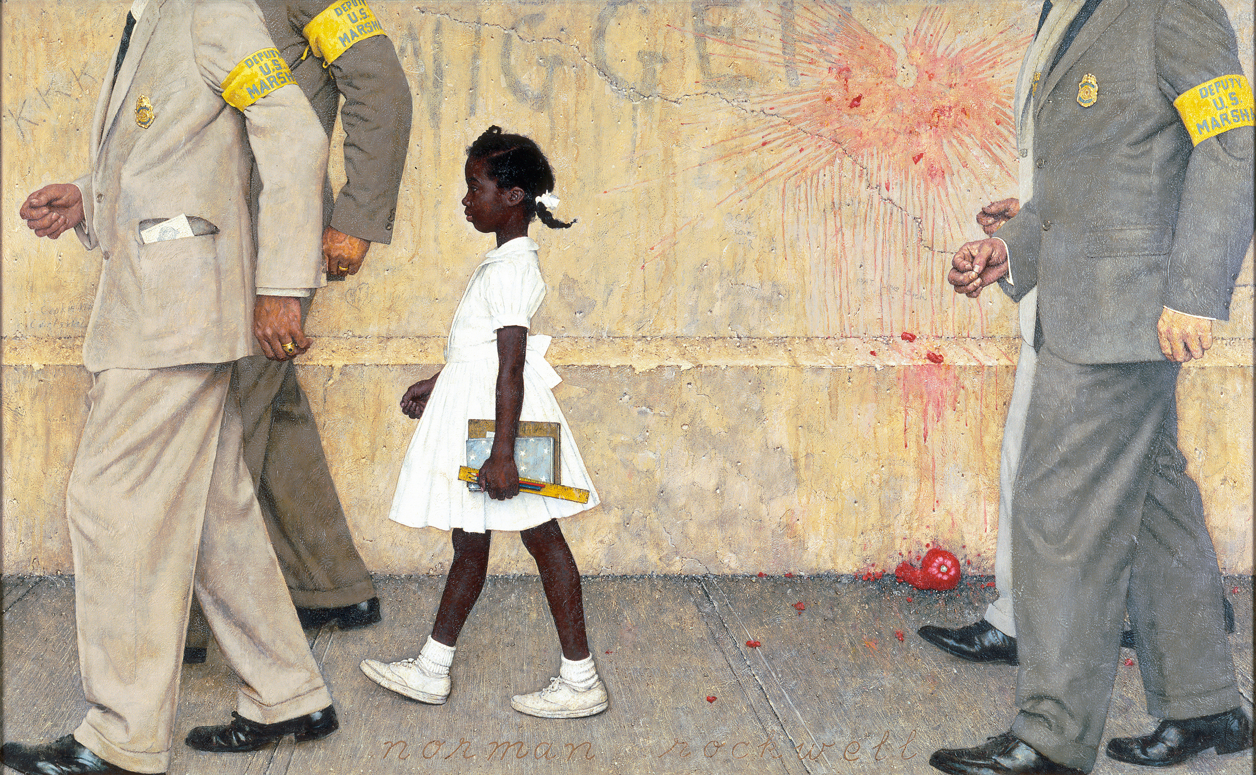

Source : Norman Rockwell painting, 1964. Detroit Institute of Arts. 14 March 2011 <http://detroit.about.com/od/museums/ss/Norman_Rockwell_3.htm>.

Julian Bond

Born into a legacy of education on January 14, 1940 in Nashville, Tennessee, Horace Julian Bond was destined to follow in great familial footsteps. His father, Horace Mann Bond, was not only an early activist against segregation, but also served as president of Lincoln University in Oxford, Pennsylvania and later as president of Atlanta University in Atlanta, Georgia.
Bond continued his family's tradition of educational excellence by attending Morehouse College in Atlanta. While a student, he helped create a literary magazine called The Pegasus and became involved in civil rights causes, most prominently starting the group Committee on Appeal for Human Rights. Bond was also one of the chief students who formed the Student Nonviolent Coordinating Committee (SNCC), for which he was the communications director.
The SNCC prompted Bond to run for office, believing it was crucial for the community to see blacks in political and governmental positions. Bond was elected to the Georgia House of Representatives. He was barred from taking his seat, largely because of his vehement statements opposing the Vietnam War. However, the Supreme Court ruled that he be allowed to take office and he served four terms as a representative. His life took an unexpected turn during the 1968 presidential election when the Democrats nominated him as a vice-presidential candidate, making him the first African American to receive such an honor. His political career continued when he was elected to the Georgia state Senate in 1976.
Throughout his political reign, Bond remained committed to Civil Rights causes as well as higher education. He taught at many prestigious universities, including Drexel, the University of Virginia and Harvard. He is a much-published author, with works that include Black Candidates: Southern Campaign Experiences, A Time To Speak, A Time To Act: The Movement in Politics, and Gonna Sit at the Welcome Table: A Documentary History of the Civil Rights Movement (with Andrew Lewis).
Bond has served as chairman of the NAACP since 1998 and is still an active supporter of human rights. Bond is also Chairman of the Premier Auto Group (PAG) (Volvo, Land Rover, Aston-Martin, Jaguar) Diversity Council and serves on the Boards of People for the American Way. He is President Emeritus of the Southern Poverty Law Center and is a Distinguished Scholar in Residence at American University in Washington, D.C. He was awarded the National Freedom Award in 2002.

Source: Julian Bond. NAACP Bold Dreams Big Victories. The People. NAACP. 14 March 2011<http://www.naacphistory.org/#/bio_detail/105>.

Martin luther king, jr.

Martin Luther King, Jr., (January 15, 1929-April 4, 1968) was born Michael Luther King, Jr., but later had his name changed to Martin. His grandfather began the family's long tenure as pastors of the Ebenezer Baptist Church in Atlanta, serving from 1914 to 1931; his father has served from then until the present, and from 1960 until his death Martin Luther acted as co-pastor. Martin Luther attended segregated public schools in Georgia, graduating from high school at the age of fifteen; he received the B. A. degree in 1948 from Morehouse College, a distinguished Negro institution of Atlanta from which both his father and grandfather had graduated. After three years of theological study at Crozer Theological Seminary in Pennsylvania where he was elected president of a predominantly white senior class, he was awarded the B.D. in 1951. He enrolled in graduate studies at Boston University, completing his residence for the doctorate in 1953 and receiving the degree in 1955. In Boston he met and married Coretta Scott, a young woman of uncommon intellectual and artistic attainments. Two sons and two daughters were born into the family.
In 1954, Martin Luther King became pastor of the Dexter Avenue Baptist Church in Montgomery, Alabama. Always a strong worker for civil rights for members of his race, King was, by this time, a member of the executive committee of the National Association for the Advancement of Colored People, the leading organization of its kind in the nation. He was ready, then, early in December, 1955, to accept the leadership of the first great Negro nonviolent demonstration of contemporary times in the United States, the bus boycott described by Gunnar Jahn in his presentation speech in honor of the laureate. The boycott lasted 382 days. On December 21, 1956, after the Supreme Court of the United States had declared unconstitutional the laws requiring segregation on buses, Negroes and whites rode the buses as equals. During these days of boycott, King was arrested, his home was bombed, he was subjected to personal abuse, but at the same time he emerged as a Negro leader of the first rank.
In 1957 he was elected president of the Southern Christian Leadership Conference, an organization formed to provide new leadership for the now burgeoning civil rights movement. The ideals for this organization he took from Christianity; its operational techniques from Gandhi. In the eleven-year period between 1957 and 1968, King traveled over six million miles and spoke over twenty-five hundred times, appearing wherever there was injustice, protest, and action; and meanwhile he wrote five books as well as numerous articles. In these years, he led a massive protest in Birmingham, Alabama, that caught the attention of the entire world, providing what he called a coalition of conscience. and inspiring his "Letter from a Birmingham Jail", a manifesto of the Negro revolution; he planned the drives in Alabama for the registration of Negroes as voters; he directed the peaceful march on Washington, D.C., of 250,000 people to whom he delivered his address, "l Have a Dream", he conferred with President John F. Kennedy and campaigned for President Lyndon B. Johnson; he was arrested upwards of twenty times and assaulted at least four times; he was awarded five honorary degrees; was named Man of the Year by Time magazine in 1963; and became not only the symbolic leader of American blacks but also a world figure.
At the age of thirty-five, Martin Luther King, Jr., was the youngest man to have received the Nobel Peace Prize. When notified of his selection, he announced that he would turn over the prize money of $54,123 to the furtherance of the civil rights movement.
On the evening of April 4, 1968, while standing on the balcony of his motel room in Memphis, Tennessee, where he was to lead a protest march in sympathy with striking garbage workers of that city, he was assassinated.

Source: “Biography: Martin Luther King, Jr.” The Nobel Prize in Peace 1964. Nobelprize.org. 11 March 2011 <http://nobelprize.org/nobel_prizes/peace/laureates/1964/king-bio.html>.

stokely carmichael
Kwame Ture, was the flamboyant civil rights leader known to most Americans as Stokely Carmichael. He is best remembered for his use of the phrase "black power," which in the mid-1960's ignited a white backlash and alarmed an older generation of civil rights leaders, including the Rev. Dr. Martin Luther King Jr.
Though his active participation in the struggle for civil rights lasted barely a decade, he was a charismatic figure in a turbulent time, when real violence and rhetoric escalated on both sides of the color line.
Stokely Carmichael was inspired to participate in the civil rights movement by the bravery of those blacks and whites who protested segregated service with sit-ins at lunch counters in the South.
"When I first heard about the Negroes sitting in at lunch counters down South," he told Gordon Parks in Life magazine in 1967, "I thought they were just a bunch of publicity hounds. But one night when I saw those young kids on TV, getting back up on the lunch counter stools after being knocked off them, sugar in their eyes, ketchup in their hair -- well, something happened to me. Suddenly I was burning."
Rejecting scholarships from several white universities, he entered Howard University in Washington in 1960. By the end of his freshman year, he had joined the Freedom Rides of the Congress of Racial Equality, hazardous bus trips of blacks and whites that challenged segregated interstate travel in the South. The Freedom Riders often met with violence, and at their destinations Carmichael and the others were arrested and jailed, the first incarcerations he experienced. One early arrest brought him a particularly harsh 49-day sentence in Parchman Penitentiary in Mississippi.
Graduating with a bachelor's degree in philosophy from Howard in 1964, he joined the Student Nonviolent Coordinating Committee. It was "Freedom Summer" in the year that SNCC (popularly pronounced snick) was sending hundreds of black and white volunteers to the South to teach, set up clinics and register disenfranchised black Southerners.
As a SNCC field organizer in Lowndes County in Alabama, where blacks were in the majority but politically powerless, he helped raise the number of registered black voters to 2,600 from a mere 70, or 300 more than the number of registered whites.
The young Carmichael was radicalized by his experiences working in the segregated South, where peaceful protesters were beaten, brutalized and sometimes killed for seeking the ordinary rights of citizens. He once recalled watching from his hotel room in a little Alabama town while nonviolent black demonstrators were beaten and shocked with cattle prods by the police.
Horrified, he said that he screamed and could not stop.
Carmichael was arrested so often as a nonviolent volunteer that he lost count after 32. His growing impatience with the tactics of passive resistance was gaining support, and in 1966 he was chosen as chairman of SNCC, replacing John Lewis, a hardworking integrationist who is now a Congressman from Georgia.
Barely a month after his selection, Carmichael, then just 25, raised the call for black power, thereby signaling a crossroads in the civil rights struggle. Increasingly uncomfortable with Dr. King's resolute nonviolence, he sensed a shift among some younger blacks in the direction of black separatism. Many were listening sympathetically to the urgings of Malcolm X, who had been assassinated a year and a half earlier, that the struggle should be carried out by any means necessary.
It was June 16, 1966, and Carmichael, a spellbinding orator, was addressing a crowd of 3,000 in a park in Greenwood, Miss. James Meredith, who had integrated the University of Mississippi, was wounded on his solitary "Walk Against Fear" from Memphis to Jackson, and volunteers were marching in his place. When they set up camp in Greenwood, Carmichael was arrested and his frustration was obvious.
"This is the 27th time," he said in disgust after his release. "We been saying 'Freedom' for six years," he continued, referring to the chant that movement protesters used as they stood up to racist politicians and hostile policemen pointing water hoses and unleashing snarling dogs. "What we are going to start saying now is 'Black Power!' "
The crowd quickly took up the phrase. "Black Power!" it repeated in a cry that would soon be echoed in communities from Oakland to Newark. But if Carmichael's call for black power galvanized many young blacks, it troubled others, who thought it sounded anti-white, provocative and violent. And it struck fear into many whites.
Adverse reaction was powerful and immediate. After the integrationist, nonviolent speeches and sermons of Dr. King and others, few Americans, white or black, were prepared for the uncompromising demands of black militants who rallied to Carmichael's cry.
Many black leaders of the civil rights movement, though eager to avoid a split, were clearly upset by the use of the phrase and the separatism it seemed to advocate.
In the book "Black Power," which Carmichael wrote in 1967 he tried to explain the term. "It is a call for black people in this country to unite, . . .to recognize their heritage, to build a sense of community. It is a call for black people to define their own goals, to lead their own organizations." And as civil unrest flared in Detroit and Newark, Carmichael's call became associated, as Hamilton put it, "with riots and guns and 'burn, baby, burn.' "
Instead of young people singing "We Shall Overcome," new images of militant black men and women were being shown on television -- black berets, raised fists, men with guns. And along with goals of social justice and integration came ideas of black separatism and power harking back to the black nationalism that had been preached in the 1920's by Marcus Garvey.
In 1967 a declining SNCC severed all ties with him. Soon after, he became honorary prime minister of the Black Panthers, the ultra-militant urban organization begun by Huey P. Newton and Bobby Seale. But he soon found himself embroiled with Panther leaders for opposing their decision to seek support among whites. He moved to Guinea, in West Africa, in 1969, saying, "America does not belong to the blacks," and calling on all black Americans to follow his example.
In July 1969, three months after he moved to Africa, he made public a letter announcing his resignation from the Black Panther Party because of what he called "its dogmatic party line favoring alliances with white radicals."

Adapted from an article by MICHAEL T. KAUFMAN, “Stokely Carmichael, Rights Leader Who Coined 'Black Power,' Dies at 57” The New York Times. 14 March 2011 <http://www.interchange.org/Kwameture/nytimes111698.html>.

Malcolm x

Malcolm X was initially known for his controversial stance of racial separatism, but after his pilgrimage to Mecca, while he still advocated Black Nationalism, he also accepted a more orthodox Islam view of the "true brotherhood" of man. He came to believe that there was a potential for cross-racial alliance.
Named Malcolm Little by his parents, Malcolm X was born on May 19, 1925 in Omaha, Nebraska. Malcolm’s father, Earl Little, was an outspoken supporter of the Black Nationalist Marcus Garvey. As a result, he received numerous death threats and was forced to move his family several times.
While the family was in Lansing, Michigan, their home was burned down. Two years later, Malcolm’s father was murdered. Malcolm’s mother had an emotional breakdown and was unable to care for Malcolm and his siblings. The children were split up and sent to foster homes.
By the time that Malcolm was a teenager, he had dropped out of high school. At first, he worked odd jobs in Boston, Massachusetts, but he soon moved to Harlem, New York and became involved in criminal activity. Malcolm moved back to Boston and shortly thereafter, he was convicted of burglary in 1946.
While Malcolm was in prison, he converted to the Muslim religious sect, the Nation of Islam. When he was released in 1952, he changed his last name to X because he considered the name “Little” to have been a slave name. The Nation of Islam’s leader, Elijah Muhammad, made Malcolm a minister and sent him around the country on speaking engagements. Malcolm spoke about black pride and separatism, and rejected the civil rights movement’s focus on integration and equality.
Malcolm was a charismatic speaker, and soon was able to use newspaper columns, television, and radio to spread the Nation of Islam’s message. Membership to the Nation of Islam increased dramatically because of Malcolm's speeches. However, while many blacks were embracing his message, civil rights leaders rejected him. Malcolm also became a concern of the government. The Federal Bureau of Investigation began surveillance of him and infiltrated the Nation of Islam.
In March 1964, Malcolm left the Nation of Islam and founded the Muslim Mosque, Inc. A month later, he took a pilgrimage to Mecca, Saudi Arabia. It was there that his view of separatism changed. He discovered that white and black Muslims could coexist together. While he still advocated Black Nationalism, he also accepted a more orthodox Islam view of the "true brotherhood" of man and believed that there was a potential for cross-racial alliance.
When he returned to the United States, he stopped advocating separatism, and instead relayed the message of integration and world brotherhood. However, he discovered that the Nation of Islam wanted to assassinate him. On February 14, 1965, his home was firebombed, but no one was hurt.
A few days later on February 21, 1965, while Malcolm was on stage at the Manhattan Audubon Ballroom, three gunmen shot him to death. The gunmen were arrested and convicted. It was later discovered that they were members of the Nation of Islam. Malcolm was buried on February 27, 1965 in Hartsdale, New York.
Since his death his popularity has continued, and is partly due to the publication of The Autobiography of Malcolm X and Spike Lee’s 1992 movie, Malcolm X.

Source: Biography of Malcolm X. About.com. 14 March 2011 <http://afroamhistory.about.com/cs/malcolmx/a/bio_x_malcolm.htm>.

Fannie Lou Hamer
The youngest of 20 children, born to Mississippi sharecropper parents, Fannie Hamer had only 6 years of schooling (a year of schooling being only 4 months for black students then) and was a polio victim, yet she became one of the most recognized women of the civil rights movement in the early '60's.
Hardships abounded for Fannie as a child. When her father was able to finally purchase two mules to help with the farming chores, they were poisoned by whites in order to "teach a lesson" in maintaining one's place. African-Americans were treated as if they were less than the family dog by whites, even though slavery had been abolished for nearly 100 years. Fannie knew that feeling, and she knew what it was to be treated as less than an animal.
In 1962, when Hamer was 44 years old, SNCC volunteers came to town and held a voter registration meeting. She was surprised to learn that African-Americans actually had a constitutional right to vote. When the SNCC (Student Non-Violent Coordinating Committee) members asked for volunteers to go to the courthouse to register to vote, Hamer was the first to raise her hand. This was a dangerous decision. She later reflected, "The only thing they could do to me was to kill me, and it seemed like they'd been trying to do that a little bit at a time ever since I could remember.”
When Hamer and others went to the courthouse, they were jailed and beaten by the police. Hamer's courageous act got her thrown off the plantation where she was a sharecropper. She also began to receive constant death threats and was even shot at. Still, Hamer would not be discouraged. She became a SNCC Field Secretary and traveled around the country speaking and registering people to vote.
Hamer co-founded the Mississippi Freedom Democratic Party (MFDP). In 1964, the MDFP challenged the all-white Mississippi delegation to the Democratic National Convention. Hamer spoke in front of the Credentials Committee in a televised proceeding that reached millions of viewers. She told the committee how African-Americans in many states across the country were prevented from voting through illegal tests, taxes and intimidation. As a result of her speech, two delegates of the MFDP were given speaking rights at the convention and the other members were seated as honorable guests.
Deeply committed to improving life for poor minorities in her state, Hamer, working with the National Council of Negro Women and others, helped organize food cooperatives and other services. She continued political activities as well, helping to convene the National Women's Political Caucus in the 1970s. She is buried in her home town of Ruleville, Mississippi, where her tombstone reads, "I am sick and tired of being sick and tired."
Sources:
“Fannie Lou Hamer.” Six Years of the Student NonViolence Coordinating Committee. 14 March 2011 <http://www.ibiblio.org/sncc/hamer.html>.

“Fannie Lou Hamer.” Women of the Hall. National Women’s Hall of Fame. 14 March 2011 <http://www.greatwomen.org/women.php?action=viewone&id=72>.

ROSA PARKS
Rosa Louise Parks was nationally recognized as the "mother of the modern day civil rights movement" in America. Her refusal to surrender her seat to a white male passenger on a Montgomery, Alabama bus, December 1, 1955, triggered a wave of protest December 5, 1955 that reverberated throughout the United States. Her quiet courageous act changed America, its view of black people and redirected the course of history.
Mrs. Parks was born Rosa Louise McCauley, February 4, 1913 in Tuskegee, Alabama. She was the first child of James and Leona Edwards McCauley. Her brother, Sylvester McCauley, now deceased, was born August 20, 1915. Later, the family moved to Pine Level, Alabama where Rosa was reared and educated in the rural school. When she completed her education in Pine Level at age eleven, her mother, Leona, enrolled her in Montgomery Industrial School for Girls (Miss White's School for Girls), a private institution. After finishing Miss White's School, she went on to Alabama State Teacher's College High School. She, however, was unable to graduate with her class, because of the illness of her grandmother Rose Edwards and later her death.
As Rosa Parks prepared to return to Alabama State Teacher's College, her mother also became ill, therefore, she continued to take care of their home and care for her mother while her brother, Sylvester, worked outside of the home. She received her high school diploma in 1934, after her marriage to Raymond Parks, December 18, 1932. Raymond, now deceased was born in Wedowee, Alabama, Randolph County, February 12, 1903, received little formal education due to racial segregation. He was a self-educated person with the assistance of his mother, Geri Parks. His immaculate dress and his thorough knowledge of domestic affairs and current events made most think he was college educated. He supported and encouraged Rosa's desire to complete her formal education.
Mr. Parks was an early activist in the effort to free the "Scottsboro Boys," a celebrated case in the 1930's. Together, Raymond and Rosa worked in the National Association for the Advancement of Colored People (NAACP's) programs. He was an active member and she served as secretary and later youth leader of the local branch. At the time of her arrest, she was preparing for a major youth conference.
After the arrest of Rosa Parks, black people of Montgomery and sympathizers of other races organized and promoted a boycott of the city bus line that lasted 381 days. Dr. Martin Luther King, Jr. was appointed the spokesperson for the Bus Boycott and taught nonviolence to all participants. Contingent with the protest in Montgomery, others took shape throughout the south and the country. They took form as sit-ins, eat-ins, swim-ins, and similar causes. Thousands of courageous people joined the "protest" to demand equal rights for all people.
Mrs. Parks moved to Detroit, Michigan in 1957. In 1964 she became a deaconess in the African Methodist Episcopal Church (AME).
Congressman John Conyers First Congressional District of Michigan employed Mrs. Parks, from 1965 to 1988. In February, 1987, she co-founded the Rosa and Raymond Parks Institute for Self Development with Ms. Elaine Eason Steele in honor of her husband, Raymond (1903-1977). The purpose is to motivate and direct youth not targeted by other programs to achieve their highest potential. Rosa Parks sees the energy of young people as a real force for change. It is among her most treasured themes of human priorities as she speaks to young people of all ages at schools, colleges, and national organizations around the world.
The Rosa and Raymond Parks Institute for Self Development's "Pathways to Freedom program, traces the underground railroad into the civil rights movement and beyond. Youth, ages 11 through 17, meet and talk with Mrs. Parks and other national leaders as they participate in educational and historical research throughout the world. They journey primarily by bus as "freedom riders" did in the 1960's,the theme: "Where have we been? Where are we going?"
As a role model for youth she was stimulated by their enthusiasm to learn as much about her life as possible. A modest person, she always encourages them to research the lives of other contributors to world peace. The Institute and The Rosa Parks Legacy are her legacies to people of good will.
Mrs. Parks received more than forty-three honorary doctorate degrees, including one from SOKA UNIVERSITY, Tokyo Japan, hundreds of plaques, certificates, citations, awards and keys to many cities. Among them are the NAACP's Spingarn Medal, the UAW's Social Justice Award, the Martin Luther King, Jr. Non - Violent Peace Prize and the ROSA PARKS PEACE PRIZE in 1994, Stockholm Sweden, to name a few. In September 1996 President William J. Clinton, the forty second President of the United States of America gave Mrs. Parks the MEDAL OF FREEDOM, the highest award given to a civilian citizen.
Published Act no.28 of 1997 designated the first Monday following February 4, as Mrs Rosa Parks' Day in the state of Michigan, her home state. She is the first living person to be honored with a holiday.
She was voted by Time Magazine as one of the 100 most Influential people of the 20th century. A Museum and Library is being built in her honor, in Montgomery, AL and will open in the fall of the year 2000 (ground breaking April 21, 1998). On September 2, 1998 The Rosa L. Parks Learning Center was dedicated at Botsford Commons, a senior community in Michigan. Through the use of computer technology, youth will mentor seniors on the use of computers. (Mrs. Parks was a member of the first graduating class on November 24, 1998). On September 26, 1998 Mrs. Parks was the recipient of the first International Freedom Conductor's Award by the National Underground Railroad Freedom Center in Cincinnati, Ohio.
Mrs. Parks has written four books, Rosa Parks: My Story: by Rosa Parks with Jim Haskins, Quiet Strength by Rosa Parks with Gregory J. Reed, Dear Mrs. Parks: A Dialogue With Today's Youth by Rosa Parks with Gregory J, Reed, this book received the NAACP's Image Award for Outstanding Literary Work, (Children's) in 1996 and her latest book, I AM ROSA PARKS by Rosa Parks with Jim Haskins, for preschoolers.
A quiet exemplification of courage, dignity, and determination; Rosa Parks was a symbol to all to remain free. Rosa Parks died on October 24, 2005.
Adapted from: Rosa Louise Parks Biography. Rosa and Raymond Parks Institute for Self-Development. 14 March 2011 <http://www.rosaparks.org/index.php?option=com_content&view=article&id=118&Itemid=60>.

Thurgood Marshall

Thurgood Marshall was America's leading radical. He led a civil rights revolution in the 20th century that forever changed the landscape of American society. But he is the least well known of the three leading black figures of this century. Martin Luther King Jr., with his preachings of love and non-violent resistance, and Malcolm X, the fiery street preacher who advocated a bloody overthrow of the system, are both more closely associated in the popular mind and myth with the civil rights struggle. But it was Thurgood Marshall, working through the courts to eradicate the legacy of slavery and destroying the racist segregation system of Jim Crow, who had an even more profound and lasting effect on race relations than either King or X.

It was Marshall who ended legal segregation in the United States. He won Supreme Court victories breaking the color line in housing, transportation and voting, all of which overturned the 'Separate-but-Equal' apartheid of American life in the first half of the century. It was Marshall who won the most important legal case of the century, Brown v. Board of Education, ending the legal separation of black and white children in public schools. The success of the Brown case sparked the 1960s civil rights movement, led to the increased number of black high school and college graduates and the incredible rise of the black middle-class in both numbers and political power in the second half of the century.
And it was Marshall, as the nation's first African-American Supreme Court justice, who promoted affirmative action -- preferences, set-asides and other race conscious policies -- as the remedy for the damage remaining from the nation's history of slavery and racial bias. Justice Marshall gave a clear signal that while legal discrimination had ended, there was more to be done to advance educational opportunity for people who had been locked out and to bridge the wide canyon of economic inequity between blacks and whites.
He worked on behalf of black Americans, but built a structure of individual rights that became the cornerstone of protections for all Americans. He succeeded in creating new protections under law for women, children, prisoners, and the homeless. Their greater claim to full citizenship in the republic over the last century can be directly traced to Marshall. Even the American press had Marshall to thank for an expansion of its liberties during the century.
Marshall's lifework, then, literally defined the movement of race relations through the century. He rejected King's peaceful protest as rhetorical fluff that accomplished no permanent change in society. And he rejected Malcolm X's talk of violent revolution and a separate black nation as racist craziness in a multi-racial society.
The key to Marshall's work was his conviction that integration -- and only integration -- would allow equal rights under the law to take hold. Once individual rights were accepted, in Marshall's mind, then blacks and whites could rise or fall based on their own ability.
Marshall's deep faith in the power of racial integration came out of a middle class black perspective in turn of the century Baltimore. He was the child of an activist black community that had established its own schools and fought for equal rights from the time of the Civil War. His own family, of an interracial background, had been at the forefront of demands by Baltimore blacks for equal treatment. Out of that unique family and city was born Thurgood Marshall, the architect of American race relations in the twentieth century.

Source: Thurgood Marshall. 14 March 2011 <http://www.thurgoodmarshall.com/home.htm>.
Medgar Evers
Medgar Evers was a native of Decatur, Mississippi, attending school there until being inducted into the U.S. Army in 1943. Despite fighting for his country as part of the Battle of Normandy, Evers soon found that his skin color gave him no freedom when he and five friends were forced away at gunpoint from voting in a local election. Despite his resentment over such treatment, Evers enrolled at Alcorn State University, majoring in business administration. While at the school, Evers stayed busy by competing on the school's football and track teams, also competing on the debate team, performing in the school choir and serving as president of the junior class.
He married classmate Myrlie Beasley on December 24, 1951, and completed work on his degree the following year. The couple moved to Mound Bayou, MS, where T.R.M. Howard had hired him to sell insurance for his Magnolia Mutual Life Insurance Company. Howard was also the president of the Regional Council of Negro Leadership (RCNL), a civil rights and pro self-help organization. Involvement in the RCNL gave Evers crucial training in activism. He helped to organize the RCNL's boycott of service stations that denied blacks use of their restrooms. The boycotters distributed bumper stickers with the slogan "Don't Buy Gas Where You Can't Use the Restroom." Along with his brother, Charles Evers, he also attended the RCNL's annual conferences in Mound Bayou between 1952 and 1954 which drew crowds of ten thousand or more.
Evers applied to the then-segregated University of Mississippi Law School in February 1954. When his application was rejected, Evers became the focus of an NAACP campaign to desegregate the school, a case aided by the U.S. Supreme Court ruling in the case of Brown v. Board of Education 347 US 483 that segregation was unconstitutional. In December of that year, Evers became the NAACP's first field officer in Mississippi.
After moving to Jackson, he was involved in a boycott campaign against white merchants and was instrumental in eventually desegregating the University of Mississippi when that institution was finally forced to enroll James Meredith in 1962.
In the weeks leading up to his death, Evers found himself the target of a number of threats. His public investigations into the murder of Emmett Till and his vocal support of Clyde Kennard left him vulnerable to attack. On May 28, 1963, a molotov cocktail was thrown into the carport of his home, and five days before his death, he was nearly run down by a car after he emerged from the Jackson NAACP office. Civil rights demonstrations accelerated in Jackson during the first week of June 1963. A local television station granted Evers time for a short speech, his first in Mississippi, where he outlined the goals of the Jackson movement. Following the speech, threats on Evers' life increased.
On June 12, 1963, Evers pulled into his driveway after returning from an integration meeting where he had conferred with NAACP lawyers. Emerging from his car and carrying NAACP T-shirts that stated, "Jim Crow Must Go", Evers was struck in the back with a bullet that ricocheted into his home. He staggered 30 feet before collapsing, dying at the local hospital 50 minutes later. Evers was murdered just hours after President John F. Kennedy's speech on national television in support of civil rights.
Mourned nationally, Evers was buried on June 19 in Arlington National Cemetery and received full military honors in front of a crowd of more than 3,000 people, the largest funeral at Arlington since John Foster Dulles. The past chairman of the American Veterans Committee, Mickey Levine, said at the services, "No soldier in this field has fought more courageously, more heroically than Medgar Evers."
On June 23, Byron De La Beckwith, a fertilizer salesman and member of the White Citizens' Council and Ku Klux Klan, was arrested for Evers' murder. During the course of his first 1964 trial, De La Beckwith was visited by former Mississippi governor Ross Barnett and one time Army Major General Edwin A. Walker.
All-white juries twice that year deadlocked on De La Beckwith's guilt, allowing him to escape justice. In response to the murder and miscarriage of justice, musician Bob Dylan wrote the song "Only a Pawn in Their Game" about Evers and his assassin. Phil Ochs wrote the songs "Too Many Martyrs" and "Another Country" in response to the killing (Evers is also mentioned in the song "Love Me I'm a Liberal"). Matthew Jones and the Student Nonviolent Coordinating Committee Freedom Singers paid tribute to Evers in the haunting "Ballad of Medgar Evers." Malvina Reynolds mentioned "the shot in Ever's back" in her song "It isn't nice".
Evers' legacy has been kept alive in a variety of ways. In 1970, Medgar Evers College was established in Brooklyn, NY as part of the City University of New York. In 1983, a made-for-television movie, For Us the Living: The Medgar Evers Story starring Howard Rollins, Jr. was aired, celebrating the life and career of Medgar Evers, and on June 28, 1992, he was immortalized in Jackson with a statue.
In 1994, thirty years after the two previous trials had failed to reach a verdict, Beckwith was again brought to trial based on new evidence concerning statements he made to others. During the trial, the body of Evers was exhumed from his grave for autopsy, and found to be in a surprisingly excellent state of preservation as a result of embalming. Beckwith was convicted on February 5, 1994, after living as a free man for three decades after the murder. Beckwith appealed unsuccessfully, and died in prison in January of 2001.
Before his body was reburied, owing to his excellent state of preservation, a new funeral was staged for Evers. This permitted his children, who were toddlers when he was assassinated and had very little memory of him, to have a chance to see him. The new funeral was covered on HBO's Autopsy series.
The 1996 film Ghosts of Mississippi tells the story of the 1994 trial, in which a District Attorney's office prosecutor, Robert Delaughter, successfully retried the case, and won.
Evers's wife, Myrlie, became a noted activist in her own right later in life, eventually serving as chairwoman of the NAACP. Medgar's brother Charles returned to Jackson in July 1963 and served briefly in his slain brother's place. Charles Evers remained involved in Mississippi Civil Rights for years to come. He resides in Jackson.

Source: NAACP History: Medgar Evers. NAACP. 14 March 2011 <http://www.naacp.org/pages/naacp-history-medgar-evers>.

NAACP
Combining the white philanthropic support that characterized Booker T. Washington's accommodationist organizations with the call for racial justice delivered by W. E. B. Du Bois's militant Niagara Movement, the NAACP forged a middle road of interracial cooperation. Throughout its existence it has worked primarily through the American legal system to fulfill its goals of full suffrage and other civil rights, and an end to segregation and racial violence. Since the end of the Civil Rights Movement of the 1950s and 1960s, however, the influence of the NAACP has waned, and it has suffered declining membership and a series of internal scandals.
The NAACP was formed in response to the 1908 race riot in Springfield, capital of Illinois and long-time home of President Abraham Lincoln. Appalled at the violence that was committed against blacks, a group of white liberals that included Mary White Ovington and Oswald Garrison Villard, both the descendants of abolitionists, issued a call for a meeting to discuss racial justice. Some 60 people, only 7 of whom were African American (including W. E. B. Du Bois, Ida B. Wells-Barnett, and Mary Church Terrell), signed the call, which was released on the centennial of Lincoln's birth. Echoing the focus of Du Bois's militant all-black Niagara Movement, the NAACP's stated goal was to secure for all people the rights guaranteed in the 13th, 14th, and 15th Amendments to the United States Constitution, which promised an end to slavery, the equal protection of the law, and universal adult male suffrage, respectively.
The NAACP established its national office in New York City and named a board of directors as well as a president, Moorfield Storey, a white constitutional lawyer and former president of the American Bar Association. The only African American among the organization's executives, Du Bois was made director of publications and research and in 1910 he established the official journal of the NAACP, The Crisis. With a strong emphasis on local organizing, by 1913 the NAACP had established branch offices in such cities as Boston, Massachusetts; Kansas City, Missouri; Washington, D.C.; Detroit, Michigan; and St. Louis, Missouri.
A series of early court battles, including a victory against a discriminatory Oklahoma law that regulated voting by means of a grandfather clause (Guinn v. United States, 1910), helped establish the NAACP's importance as a legal advocate, a role it would play with overwhelming success. The fledgling organization also learned to harness the power of publicity through its 1915 battle against D. W. Griffith's inflammatory Birth of a Nation, a motion picture that perpetuated demeaning stereotypes of African Americans and glorified the Ku Klux Klan.
Its membership grew rapidly, from around 9,000 in 1917 to around 90,000 in 1919, with more than 300 local branches. The writer and diplomat James Weldon Johnson became the association's first black secretary in 1920, and Louis T. Wright, a surgeon, was named the first black chairman of its board of directors in 1934; neither position was ever again held by a white person. Meanwhile, The Crisis became a voice of the Harlem Renaissance, as Du Bois published works by Langston Hughes, Countee Cullen, and other African American literary figures.
Throughout the 1920s the fight against lynching was among the association's top priorities. After early worries about its constitutionality, the NAACP strongly supported the federal Dyer Bill, which would have punished those who participated in or failed to prosecute lynch mobs. Though the U.S. Congress never passed the bill, or any other antilynching legislation, many credit the resulting public debate—fueled by the NAACP's report, Thirty Years of Lynching in the United States, 1889-1919—with drastically decreasing the incidence of lynching.
Johnson stepped down as secretary in 1930 and was succeeded by Walter F. White. White was instrumental not only in his research on lynching (in part because, as a very fair-skinned African American, he had been able to infiltrate white groups), but also in his successful block of segregationist Judge John J. Parker's nomination by President Herbert Hoover to the Supreme Court of the United States. Though some historians blame Du Bois's 1934 resignation from The Crisis on White, the new secretary presided over the NAACP's most productive period of legal advocacy. In 1930 the association commissioned the Margold Report, which became the basis for its successful reversal of the separate-but-equal doctrine that had governed public facilities since 1896's Plessy v. Ferguson. In 1935 White recruited Charles H. Houston as NAACP chief counsel. Houston was the Howard University law school dean whose strategy on school-segregation cases paved the way for his protégé Thurgood Marshall to prevail in 1954's Brown v. Board of Education, the decision that overturned Plessy.
During the Great Depression of the 1930s, which was disproportionately disastrous for African Americans, the NAACP began to focus on economic justice. After years of tension with white labor unions, the association cooperated with the newly formed Congress of Industrial Organizations (CIO) in an effort to win jobs for black Americans. Walter White, a friend and adviser to First Lady Eleanor Roosevelt, who was sympathetic to civil rights, met with her often in attempts to convince President Franklin D. Roosevelt to outlaw job discrimination in the armed forces, defense industries (which were booming in anticipation of U.S. entry into World War II), and the agencies spawned by Roosevelt's New Deal legislation. Though not initially successful, Roosevelt agreed to open thousands of jobs to black workers when the NAACP supported labor leader A. Philip Randolph and his March on Washington movement in 1941. Roosevelt also agreed to set up a Fair Employment Practices Committee (FEPC) to ensure compliance.
Throughout the 1940s the NAACP saw enormous growth in its membership, claiming nearly 500,000 members by 1946. It continued to act as a legislative and legal advocate, pushing (albeit unsuccessfully) for a federal antilynching law and for an end to state-mandated segregation. By the 1950s the NAACP's Legal Defense and Educational Fund, headed by Marshall, secured the last of these goals through Brown v. Board of Education (1954), which outlawed segregation in public schools. The NAACP's Washington, D.C., bureau, led by lobbyist Clarence M. Mitchell Jr., helped advance not only integration of the armed forces in 1948 but also passage of the Civil Rights Acts of 1957, 1964, and 1968, as well as the Voting Rights Act of 1965.
Despite such dramatic courtroom and congressional victories, the implementation of civil rights was a slow, painful, and sometimes violent process. The unsolved 1951 murder of Harry T. Moore, an NAACP field secretary in Florida whose home was bombed on Christmas night, was just one of many crimes of retribution against the NAACP and its staff and members during the 1950s. Violence also met black children attempting to enter previously segregated schools in Little Rock, Arkansas, and other southern cities, and throughout the South many African Americans were still denied the right to register and vote.
The Civil Rights Movement of the 1950s and 1960s echoed the NAACP's moderate, integrationist goals, but leaders such as Martin Luther King Jr., of the Southern Christian Leadership Conference (SCLC), felt that direct action was needed to obtain them. Though the NAACP was opposed to extralegal popular actions, many of its members, such as Mississippi field secretary Medgar Evers, participated in nonviolent demonstrations such as sit-ins to protest the persistence of Jim Crow segregation throughout the South. Although it was criticized for working exclusively within the system by pursuing legislative and judicial solutions, the NAACP did provide legal representation and aid to members of more militant protest groups.
Led by Roy Wilkins, who had succeeded Walter White as secretary in 1955, the NAACP cooperated with organizers A. Philip Randolph and Bayard Rustin in planning the 1963 March on Washington. With the passage of civil rights legislation the following year, the association had finally accomplished much of its historic legislative agenda. In the following years, the NAACP began to diversify its goals and, in the opinion of many, to lose its focus. Millions of African Americans continued to be afflicted as urban poverty and crime increased, de facto racial segregation remained, and job discrimination lingered throughout the United States. With its traditional interracial, integrationist approach, the NAACP found itself attracting fewer members as many African Americans became sympathetic to more militant, even separatist, philosophies, such as that espoused by the Black Power Movement.
Wilkins retired as executive director in 1977 and was replaced by Benjamin L. Hooks, whose tenure included the Bakke case (1978), in which a California court outlawed several aspects of affirmative action. At around the same time tensions between the executive director and the board of directors, tensions that had existed since the association's founding, escalated into open hostility that threatened to weaken the organization. With the 1993 selection of Benjamin F. Chavis (now Chavis Muhammad) as director, more controversies arose. In an attempt to take the NAACP in new directions, Chavis offended many liberals by reaching out to Nation of Islam leader Louis Farrakhan. After using NAACP funds to settle a sexual harassment lawsuit, Chavis was forced to resign in 1995 and subsequently joined the Nation of Islam.
At the end of the 20th century, the NAACP focused on economic development and educational programs for youths, while also continuing its role as legal advocate for civil rights issues. Kweisi Mfume, former congressman and head of the Congressional Black Caucus, is president and chief executive officer, and Julian Bond is chairman of the board. The organization currently has more than 500,000 members.

From: NAACP. Black History. Africana Online. 14 March 2011 <http://www.africanaonline.com/orga_naacp.htm>.

Student Nonviolent Coordinating Committee (SNCC)
On February 1, 1960, a group of black college students from North Carolina A&T University refused to leave a Woolworth's lunch counter in Greensboro, North Carolina where they had been denied service. This sparked a wave of other sit-ins in college towns across the South. The Student Nonviolent Coordinating Committee, or SNCC (pronounced "snick"), was created on the campus of Shaw University in Raleigh two months later to coordinate these sit-ins, support their leaders, and publicize their activities.
Over the next decade, civil rights activism moved beyond lunch counter sit-ins. In this violently changing political climate, SNCC struggled to define its purpose as it fought white oppression. Out of SNCC came some of today's black leaders, such as former Washington, D.C. mayor Marion Barry, Congressman John Lewis and NAACP chairman Julian Bond. Together with hundreds of other students, they left a lasting impact on American history.

SNCC Concerns
Nonviolence: SNCC's original statement of purpose established nonviolence as the driving philosophy behind the organization. However, things were never that simple. In the early days, during the period of the sit-in movement, nonviolent action was strictly enforced, particularly for public demonstrations, as it was key to the movement's success.

Vietnam: SNCC formally came out against the Vietnam War in the beginning of 1966 as a result of pressure from northern supporters and from members working on the southern projects. In one instance, the McComb, Mississippi project went as far as releasing its own antiwar pamphlet. Such events may have pushed SNCC towards releasing an official opinion, but the murder of Sammy Younge was the catalyst. Younge was a SNCC worker and a Tuskegee Institute Student who lost his kidney in Vietnam.

White Liberalism: Early in SNCC's history a rift began to form between the organization and its white liberal support. When SNCC initially began its program of sit-ins and other forms of nonviolent protest, they hoped it would create such a compelling image of violent oppression that northern white liberals would become incensed by the situation

Feminism: Many people feel that SNCC opened the door for the feminist movement, as it first established many of the principles later use by feminists. SNCC sought to change society by creating alternative institutions, instead of altering the existing ones. It rallied the oppressed by glorifying their qualities, and it viewed prejudice, in the form of racism or sexism, as a core social problem.

Black Power: Black Power was the guiding philosophy of SNCC in its later years. It began to develop and take hold sometime after 1964, and came to prominence in 1966 when Stokely Carmichael became head of the organization.

SNCC Participated in Numerous Events
Sit-ins: The first sit-in on February 1, 1960 in Greensboro, North Carolina, is said to have been the catalyst for an entire movement, including the birth of SNCC. Roommates Joseph McNeil and Izell Blair, and Franklin McCain and David Richmond, students at predominately black North Carolina Agricultural and Technical College were the participants.

Freedom Rides: During the Freedom Rides, SNCC members rode buses through the deep southern states where discrimination and segregation were most prominent.
.
Freedom Ballot: SNCC members viewed gaining the right to vote as a significant move towards racial equality in the South. If blacks had the power of the vote, SNCC felt they would have influence over many important aspects of southern politics. SNCC organized the Freedom Ballot in the fall of 1963 in the state of Mississippi, where racial discrimination was the strongest and black voting power was the weakest. The Freedom Ballot was a mock election to get the vote for poor southern blacks.

Mississippi Freedom Democratic Party: The Freedom Ballot set the stage for the Mississippi Summer Project, organized primarily by Bob Moses. SNCC worked hard in the winter and spring of 1963-64 preparing for the project, which was an urgent call to action for students in Mississippi to challenge and overcome the white racism in the state of Mississippi.

March on Washington: SNCC played a key role in the 1963 March on Washington where Martin Luther King, Jr. gave his famous "I have a dream" speech. A crowd of 200,000 people gathered around the Lincoln memorial in August 1963 to hear speeches by leaders of civil rights organizations, such as John Lewis. More than any other Civil Rights group, SNCC was critical of the federal government's role in the movement. While the members of the administration celebrated and cheered at the march, SNCC members felt the federal government was much quieter Deep South, where racism was barely tempered.

The SNCC Embraces “Black Power”
While at its inception the SNCC was devoted to nonviolent resistance, was influenced by Christian principles, and black and white activists worked alongside one another, some members began to challenge these views. In the mid-1960s, the SNCC was plagued by ideological debates and became influenced by Marxism and Black Nationalism.
In 1966, Stokely Carmichael, the new chairman of the SNCC, began moving the group away from passivism and more toward militancy and Black Nationalism. The earliest public signs of this occurred during the Mississippi March Against Fear. During this SNCC and SCLC joint demonstration on behalf of James Meredith, Martin Luther King and Carmichael debated vehemently in private about the term “Black Power.” The term was associated with racial pride, black unity, self-defense, and political and economic power. It was during this demonstration that Carmichael began to use the term publicly. Although King opposed the usage of the term, the slogan caught on quickly during the march.

The SNCC Falls Apart
By the late 1960s, the SNCC was unable to effectively organize civil rights protests. In 1967, Hubert “Rap” Brown was elected as the SNCC’s new chairman. Brown’s advocacy of militancy brought the organization under FBI surveillance. The group began to dissolve as many of its leaders and organizers left. In 1970, the SNCC disbanded.

Adapted from: SNCC: Six Years of the Student Nonviolent Coordinating Committee. 14 March 2011 <http://www.ibiblio.org/sncc/>; Student NonViolent Coordinating Committee. AfroAmerican History. 14 March 2011 <http://afroamhistory.about.com/od/sncc/a/sncc.htm>.

Congress of Racial Equality

The Congress of Racial Equality (CORE) was founded in 1942 as the Committee of Racial Equality by an interracial group of students in Chicago-Bernice Fisher, James R. Robinson, James L. Farmer, Jr., Joe Guinn, George Houser, and Homer Jack. Many of these students were members of the Chicago branch of the Fellowship of Reconciliation (FOR), a pacifist organization seeking to change racist attitudes. The founders of CORE were deeply influenced by Mahatma Gandhi's teachings of nonviolent resistance.

CORE started as a nonhierarchical, decentralized organization funded entirely by the voluntary contributions of its members. The organization was initially co-led by white University of Chicago student George Houser and black student James Farmer. In 1942, CORE began protests against segregation in public accommodations by organizing sit-ins. It was also in 1942 that CORE expanded nationally. James Farmer traveled the country with Bayard Rustin, a field secretary with FOR, and recruited activists at FOR meetings. CORE's early growth consisted almost entirely of white middle-class college students from the Midwest. CORE pioneered the strategy of nonviolent direct action, especially the tactics of sit-ins, jail-ins, and freedom rides.

From the beginning of its expansion, CORE experienced tension between local control and national leadership. The earliest affiliated chapters retained control of their own activities and funds. With a nonhierarchical system as the model of leadership, a national leadership over local chapters seemed contradictory to CORE's principles. Some early chapters were dominated by pacifists and focused on educational activities. Other chapters emphasized direct action protests, such as sit-ins. This tension persisted throughout CORE's early existence.

Through sit-ins and picket lines, CORE had success in integrating northern public facilities in the 1940s. With these successes it was decided that, to have a national impact, it was necessary to strengthen the national organization. James Farmer became the first National Director of CORE in 1953.

In April of 1947 CORE sent eight white and eight black men into the upper South to test a Supreme Court ruling that declared segregation in interstate travel unconstitutional. CORE gained national attention for this Journey of Reconciliation when four of the riders were arrested in Chapel Hill, North Carolina and three, including Bayard Rustin, were forced to work on a chain gang.

In the aftermath of the 1954 Brown v. Board of Education decision, CORE was revived from several years of stagnation and decline. CORE provided the 1955 Montgomery Bus Boycott with its philosophical commitment to nonviolent direct action. As the Civil Rights Movement took hold, CORE focused its energy in the South.

CORE's move into the South forced the leadership to address the question of the organization's place within the black community. Though whites still remained prominent, black leaders were sought out for high profile positions. CORE remained committed to interracialism but no longer required that new chapters have an interracial membership, largely expecting little white support in the South. While middle-class college students predominated in the early years of the organization, increasingly the membership was made up of poorer and less educated African Americans.

CORE provided guidance for action in the aftermath of the 1960 sit-in of four college students at a Greensboro, North Carolina lunch counter, and subsequently became a nationally recognized civil rights organization. As pioneers of the sit-in tactic the organization offered support in Greensboro and organized sit-ins throughout the South. CORE members then developed the strategy of the jail-in, serving out their sentences for sit-ins rather than paying bail.

In May of 1961 CORE organized the Freedom Rides, modeled after their earlier Journey of Reconciliation. Near Birmingham, Alabama a bus was firebombed and riders were beaten by a white mob. Despite this violent event, CORE continued to locate field secretaries in key areas of the South to provide support for the riders.

By the end of 1961, CORE had 53 affiliated chapters, and they remained active in southern civil rights activities for the next several years. CORE participated heavily in President Kennedy's Voter Education Project (VEP) and also co-sponsored the 1963 March on Washington. In 1964 CORE participated in the Mississippi Freedom Summer project; three activists killed that summer in an infamous case, James Chaney, Andrew Goodman and Michael Schwerner, were members of CORE.

By 1963 CORE had already shifted attention to segregation in the North and West where two thirds of the organization's chapters were located. In an effort to build CORE's credibility as a black-protest organization, leadership in these northern chapters had become almost entirely black. CORE's ideology and strategies increasingly were challenged by its changing membership. Many new members advocated militancy and believed nonviolent methods of protest were to be used only if they proved successful.

As the tactics were being questioned so was the leadership. In 1966, under mounting pressure and with the organization losing members influence and financial support, James Farmer stepped down as National Director and was replaced by the more militant Floyd McKissick. McKissick endorsed the term Black Power and was a much more acceptable leader to the Black community than Farmer was.

When McKissick took over, the organization was badly dis-organized and deep in debt. Although McKissick was a charismatic and respected leader, he was unable to turn the organization's finances around. In 1968 he announced his retirement to pursue his dream of building a "Soul City" in North Carolina and Roy Innis, who was Chairman of the Harlem Chapter of CORE, replaced him as the National Director.

Innis inherited the organization with a completely de-centralized structure, with more than a million dollars in debt and no fundraising mechanism. The organization's fundraising arm--CORE Health, Education & Welfare Fund--had deserted the organization when Farmer left. Innis quickly declared the first order of business was restructuring so that Chapters and field operatives were responsible back to the National Headquarters. Innis also developed a new fundraising arm--CORE Special Purpose Fund--and began to chip away at the organization's debt.

Under Innis's leadership, CORE embraced an ideology of pragmatic nationalism and lent its support to black economic development and community self-determination.

Source: The History of CORE. Congress of Racial Equality. 14 March 2011 <http://www.core-online.org/History/history.htm>.

Civil Rights Playoff

Team Thurgood
Marshall

Team Julian Bond

Team Malcolm X

Team Stokely
Carmichael

VS

Team Rosa Parks

Team Medgar Evers

Team Martin
Luther King, Jr.

Team Fannie
Lou Hammer

Civil Rights Playoff

VS

Background on Little Rock

In 1954, the Supreme Court ruled in Brown v. Board of Education that segregated schools were unconstitutional. In 1955, the Court reaffirmed the ruling, saying schools must be integrated "with all deliberate speed." But by 1957, many southern schools remained segregated.
Little Rock, Arkansas, seemed moderate compared to much of the South. Buses and parks were already integrated. There were black police officers and a few integrated neighborhoods, and a decade before the Voting Rights Act, a third of Little Rock's black population was registered to vote. Although much of Little Rock was still segregated, its white school board was the first in the South to comply with the Court's 1955 mandate to integrate schools.
The school board, worried about the impact of sudden change, made plans to desegregate its schools gradually over six years. The black community was frustrated that integration would take so long. The National Association for the Advancement of Colored People (NAACP) filed suit for immediate integration, but, in the meantime, white resistance was mounting.
By September 1957, 9 of the 75 black students who signed up were chosen to attend Central High School. But the night before school started, Governor Faubus announced on statewide television that "Blood will run in the streets if Negro pupils should attempt to enter Central High School," and ordered 250 Arkansas National Guardsmen to maintain order and allow only white students to enter the school.
The governor's actions shocked the people of Little Rock. He had been neutral on civil rights and even garnered support from the black community. However, the governor was also running for re-election and admitted that he needed the segregationists' vote.
Until then, President Eisenhower had been reluctant to get involved; but when an angry mob and the National Guard prevented the black students from attending school -- and when Faubus refused to guarantee their safety -- the president ordered 350 federal troops to restore order at Central High School. Faubus never conceded, and the 101st Airborne Division guarded the "Little Rock Nine" until the last day of school.
The following year, Faubus retaliated by closing the Little Rock's schools. He was re-elected to his third term as governor by an overwhelming majority.

Source: Background Essay: Little Rock Nine. Teachers' Domain: 2002-2010 WGBH Educational Foundation. PBS. 2002-2010. 14 March 2011 <http://www.teachersdomain.org/resource/iml04.soc.ush.civil.lr9/>.

Background Essay: White Resistance

Throughout the 1950s and 1960s, as the Civil Rights movement gained strength, white resistance to it grew as well. White resistance took a variety of forms, and targeted not only blacks, but also sympathetic whites.
Soon after the Brown v. Board of Education decision, local business and political leaders organized White Citizens' Councils throughout the South. Council members retaliated against integration and equal rights advocates by foreclosing mortgages, refusing loans, and firing workers. State and regional networks and a national Citizens' Council of America coordinated these efforts. James Eastland, state senator from Mississippi said, "In the last few years, there has been a number of backsliders on the segregation issue... The Citizen's Council is out to utterly destroy those people [civil rights advocates]."
Politicians throughout the South used their power to resist the Civil Rights movement. In 1956, one year after the United States Supreme Court made its implementation decision in Brown, 100 southern congressmen signed the Southern Manifesto, attacking the Court and pledging their noncompliance with its decision: "We pledge ourselves to use all lawful means to bring about a reversal of this decision which is contrary to the Constitution and to prevent the use of force in its implementation."
White resistance also took the form of widespread violence and intimidation tactics, spearheaded by groups such as the Ku Klux Klan and by local police forces. According to one Klan leader, integration would destroy the white and black races, producing "a conglomerated, mulatto, mongrel type of people." During the Mississippi Freedom Summer of 1964, Ku Klux Klan members murdered three Congress of Racial Equality (CORE) volunteers (two white, one black) who were investigating the burning of a black church. On March 7, 1965, Sheriff Jim Clark and the Selma, Alabama police violently stopped a peaceful voting rights march. Over 60 marchers were injured during the confrontation. The violence was televised nationally, and the day became known as "Bloody Sunday."
In many cases, white resistance worked to the advantage of civil rights leaders. Not only did images of violent resistance expose the deep racism that existed in the South, but they pointed out the hypocrisy of the nation's Cold War policies. During this period, the United States government used the rhetoric of freedom and democracy as a means of gaining foreign allies in the struggle against communism. Civil rights leaders hoped to put pressure on the federal government by publicly exposing the fact that the United States was promoting liberty abroad while denying African Americans civil rights at home.

Source: Background Essay: White Resistance. Teachers' Domain: 2002-2010 WGBH Educational Foundation. PBS. 2002-2010. 14 March 2011 <http://www.teachersdomain.org/resource/iml04.soc.ush.civil.resist/>.
Comparing Sources

Questions | Reading | Video
1. How does the source describe the situation?
2. When was the source produced? How might this affect the how you view the source?
3. What three questions would you like to ask the source’s creator? Why would these be important in understanding the source?

4. What is the point of view of the source? How do you know?

Evaluating the Reliability of Sources

1. What is the source of the information being considered?
2. List the factors that are relevant to the reliability of the source in the following categories:
- Publication
Date - is the information current, or does it need to be current?
Reputation of publication - is the source well known and reputable?
Kind of publication - is it a scientific report, eye-witness account, a work of fiction?
- Author or Speaker
Qualifications - is he an expert in his field?
Bias - is he one-sided in his point-of-view?
Values - what does the author value in regards to the topic?
Chance for personal gain - does the author stand to benefit from his position?

- Consistency of Information
Confirmation or corroboration - can anyone else make the same claims?

- Means of Obtaining the Information
Witness or researcher - was the author or speaker a first-hand witness to the information or did he gather it from some other source?
Equipment - what kind of equipment was used to record information?
3. Answer as many of the questions as you can, and determine if the answer would indicate a reliable source, an unreliable source, or an uncertainty for each.
4. Weigh the factors present and your ratings of the evidence and make a reasoned judgment of reliability of the source.

Source: Evaluating the Reliability of Sources. Consider the Source. 14 March 2011 <http://www.kyrene.k12.az.us/schools/brisas/sunda/webquest/evaluating_reliability.htm>.
Little Rock Resource Packet
Letters, documents, records, diaries, drawings, newspaper accounts and other bits and pieces left behind by those who have passed on — are treasures to the historian. These are primary sources that can give up the secrets of life in the past. Historians learn to read these sources.
But reading a source for evidence demands a different approach than reading a source for information. The contrast may be seen in an extreme way in the difference between reading a phone book — for information — and examining a boot-print in the snow outside a murder scene —for evidence. When we look up a phone number, we don’t ask ourselves, “who wrote this phonebook?” or “what impact did it have on its readers?” We read it at face value. The boot print, on the other hand, is a trace of the past that does not allow a comparable reading. Once we establish what it is, we examine it to see if it offers clues about the person who was wearing the boot, when the print was made, which direction the person was headed, and what else was going on at that time.
A history textbook is generally used more like a phone book: it is a place to look up information. Primary sources must be read differently. To use them well, we set them in their historical contexts and make inferences from them to help us understand more about what was going on when they were created.
Your Task: Divide the sources among your group members. Individually, use the framework “Evaluating the Reliability of Sources” to evaluate your sources. Share the results of your analysis with your group. After each source is explored, answer the questions below as a group.

  - Which two sources are the least reliable? Why?

  - Which two sources are most reliable? Why?

  - Which source is the most biased? In what way is it biased? Why?

  - Which source best demonstrates the experience of the African American students? Why?

  - Which two sources best demonstrate the conflict between state and federal governments? Why?

  - Which two sources provide the best evidence about what happened in Little Rock? Explain.

Source #1: The Denver Post, September 5, 1957
Editorial: The Arkansas Trampler

The governor of Arkansas, in defiance of a federal court order, is attempting to bar Negroes from attending a Little Rock high school...

He has denied that he is defying Federal District Judge Ronald N. Davies, who has ordered integration of the Little Rock high school on a gradual and limited basis. The governor insists that he is, rather, only using the Arkansas national guard to keep "peace and order..."

...From the facts now at hand, the governor's actions appear to have been impulsive, unwarranted and deliberately provocative. He has revealed himself as a stooge of militant minorities aligned with bigots to trample civil rights in a phony defense against imaginary evils. Arkansas deserves better.

____________________________________________________________________________________________

Source #2: The Birmingham Post-Herald, September 5, 1957
Editorial: An Inevitable Clash

Important, far-reaching legal precedents could come out of the action of the governor of Arkansas in calling out the National Guard to block integration of a Little Rock school.

Governor Faubus says the guardsmen are on duty to preserve peace and maintain order.

Certainly that is one of his responsibilities as governor.

There is little room for doubt that public sentiment in Arkansas supports Governor Faubus. A majority of the people not only in Arkansas but throughout the South are opposed to the integration of the schools...

...Their attitude is not one of revolt or arbitrary refusal to bow to authority which always they have respected and upheld. But underlying it is a deep sense of injustice and a determination too often underestimated and widely misunderstood...

...As the President pointed out, you do not change people's hearts merely by laws. He might have added, nor by mere law can you expect to change overnight a region's deep-rooted way of life.
_______________________________________________________________________________________________

Source #3: The Boston Globe, mid-September, 1957
Editorial: The Ordeal at Little Rock

The situation in Little Rock has put a hard line around the amorphous but firm resistance of the South to the Federal court order for integration into the hitherto all-white schools. Perhaps, in the long run, the blundering procedure of Gov. Orval Faubus may precipitate resolution of the remaining legal questions delaying the inevitable death of segregation in public schools...

...Of course the Federal government is not going to arrest the governor, nor march in troops to force a high school doorway. The South, as well as the North, is a country of law and its respect for the law will prevail...

Source: Southern School Desegregation. Press. Eyes on the Prize. American Experience. PBS. 14 March 2011 <http://www.pbs.org/wgbh/amex/eyesontheprize/story/03_schools.html>.

_______________________________________________________________________________________________

Source # 4: Ernest Green, the first black graduate of Little Rock Central High School, in a 1962 interview as he responds to a reporters’ question about what he remembered most about his first day at Central High.
"In looking through my clippings, I think of all the things that have happened at Central, the most significant thing was the friendly attitude that students showed toward me the day of the rioting. The type of thing that was going on outside, people beaten, cursed, the mob hysterics and all of this going on outside...we inside the school didn't realize the problems that were occurring and continually students were befriending us.
I remember one case in particular in my physics class. I was three weeks behind in my assignments, and a couple of fellows offered to give me notes and to help me catch up the work that I had missed. I was amazed at this kind of attitude being shown toward the Negroes."
Source: “Ernest Green’s Memories of Little Rock.” Little Rock Central High. The 1957-1958 School Year. 14 March 2011 <http://centralhigh57.org/movie2.htm>.

Source #5: (CNN) -- Elizabeth Eckford recently sat down with CNN and recalled the events of the 1957-58 school year, when she and eight other African-American teenage students were chosen to attend Central High School.
Monday, May 17, 2004 Posted: 11:30 AM EDT <http://www.cnn.com/2004/LAW/05/17/eckford.transcript/index.html>

CNN: And the atmosphere at school for you that first year?
ECKFORD: You know about the Plague of the Three Monkeys? Hear no evil, see no evil and do no evil? All of the students who said, that we see nowadays, that say they went to school there? Say, "Wasn't me, wasn't me. I wasn't one of those attacking you." (shaking head)
We were physically assaulted every day. The principal's rule was that, no matter what was reported, he wouldn't act on any reports if a teacher didn't corroborate what we said happened. So, in essence, students had free reign to attack us every day. It was a coordinated group of about 55 students who attacked us out of 1,900 students at the school.
A lot of people think, "We didn't know what was going on." People around me that I saw didn't react to what they saw or what they had to have heard. They turned their backs. It was impossible to have a friend. This was not anything like a normal environment. Anybody that would talk to us got a lot of pressure.
There's two students I want to talk about that persisted in talking to me in speech class. Actually I was a very, very shy person, but I felt comfortable, felt that I belonged in that one class. At the end of the day, two people treated me like a human being. (starts to cry). And when they just ... they persisted in talking to me every day like any other student. They didn't ask me something to see what "it" sounded like. They just talked to me.
I didn't know what happened to them. I knew something had to be happening to them. I didn't find out until 1996 what had happened to them. There was a boy and there was a girl. The boy was a senior, and there's a graduation picture of him standing next to Ernest Green (one of the Little Rock Nine) and a bunch of students in the background looking at them and talking about them, just 'cause he was standing near Ernest Green.
But I found out in '96, because I had talked about these students over the years. In the '60s I started naming them. So, they had heard about me, and what it meant to me.
One girl named Ann Williams I found out didn't live in Little Rock. She said her family lived on a farm outside the city, and that her father had to hire armed guards for their home.
And the other student is Ken Reinhardt. Ken was harassed. He'd been knocked down, one time, he said, right in front of the gym teacher and the gym teacher did nothing.
There have been one or two students who've acknowledged seeing in the boy's gym, in the shower room, that the Negro boys were hit with hot, wet, knotted towels. Broken glass on the shower room floor.
I remember the few times we were scalded in the shower room. I didn't hear a peep from either girl on either side of me. We had open stalls in the shower. So they'd been warned.
Anyway, school ended May 28, 1958.
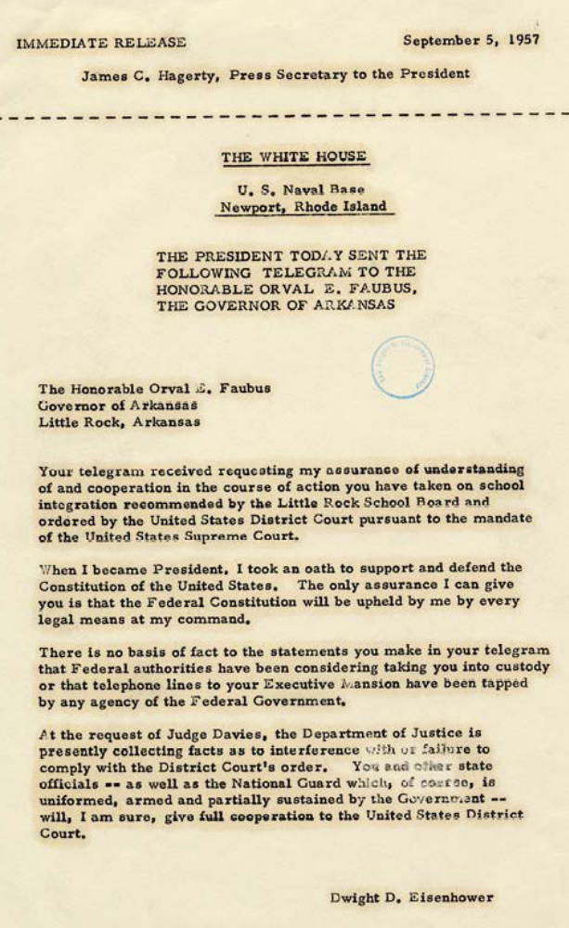
Source #6:
Press release, President Eisenhower's telegram to Governor Faubus, September 5, 1957
Source 7: Press release, statement by President Eisenhower from Newport, Rhode Island, Sept. 14, 1957

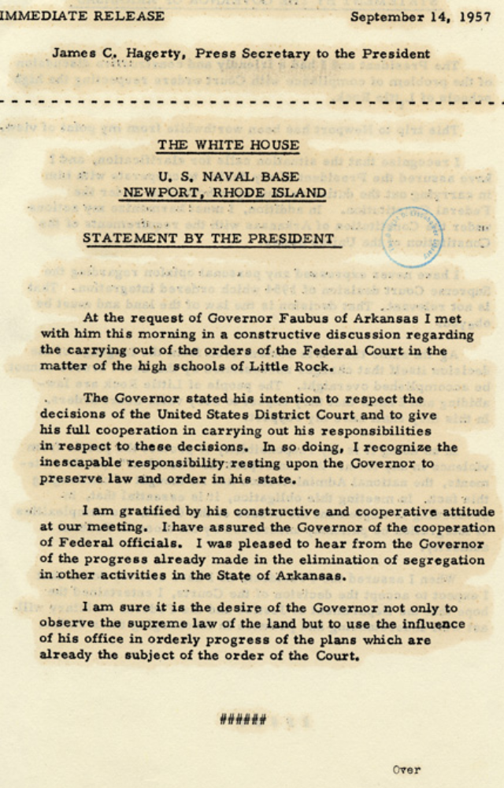
Source 8: Press release, statement by Governor Faubus from Newport, Rhode Island, September 14, 1957
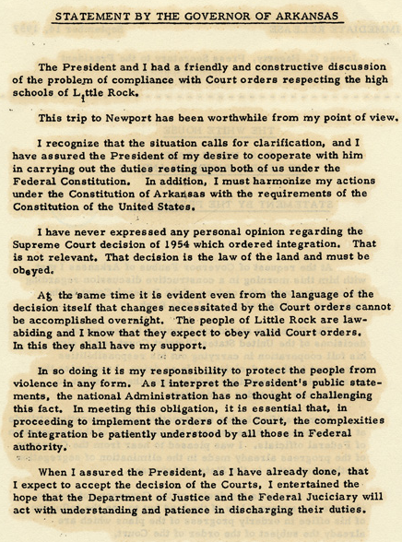

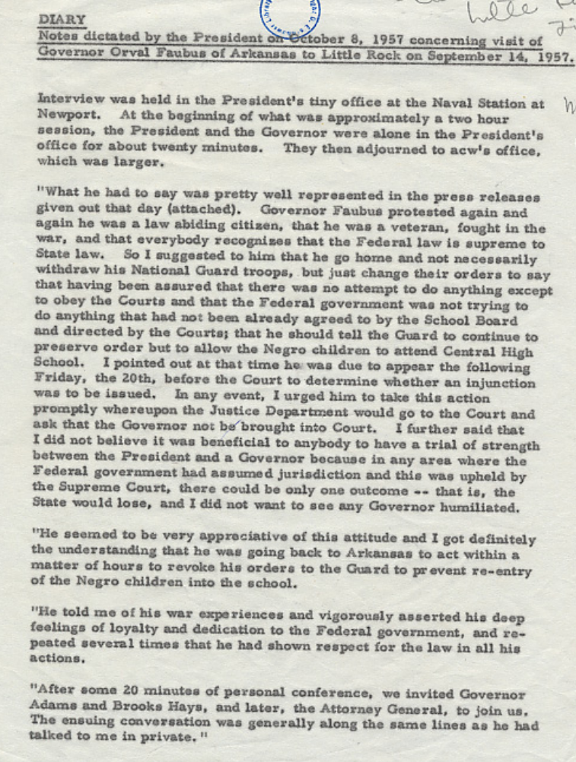
Source #9:
Diary - notes dictated by President Eisenhower on October 8, 1957 concerning meeting with Governor Faubus at Newport, Rhode Island, September 14, 1957

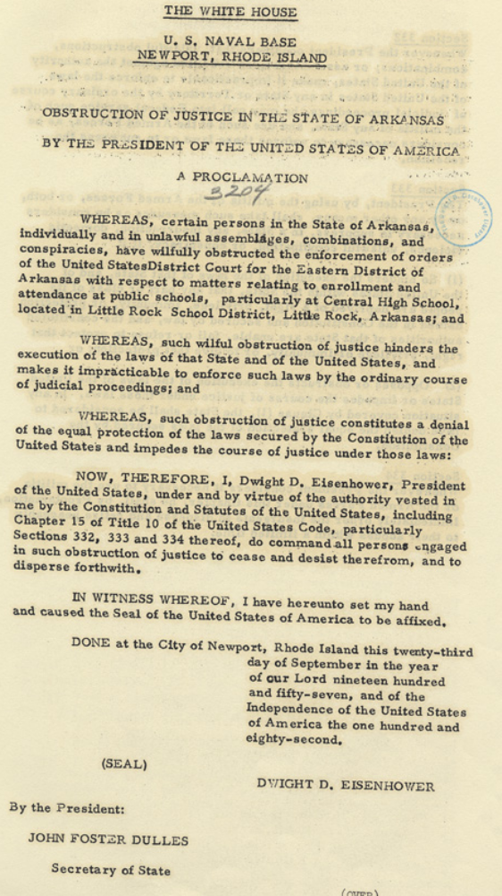
Source #10:
Press release, Proclamation 3204, Obstruction of Justice in the State of Arkansas, by the President of the United States of America, September 23, 1957

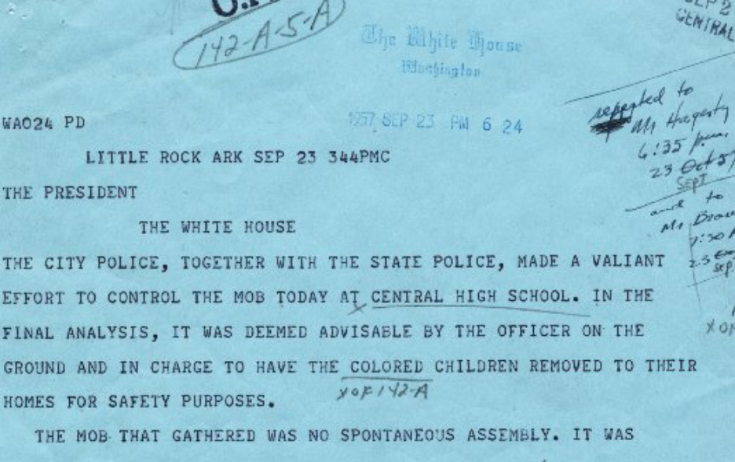
Source #11:
Telegram, Woodrow Wilson Mann, Mayor of Little Rock, to President Eisenhower, September 23, 1957

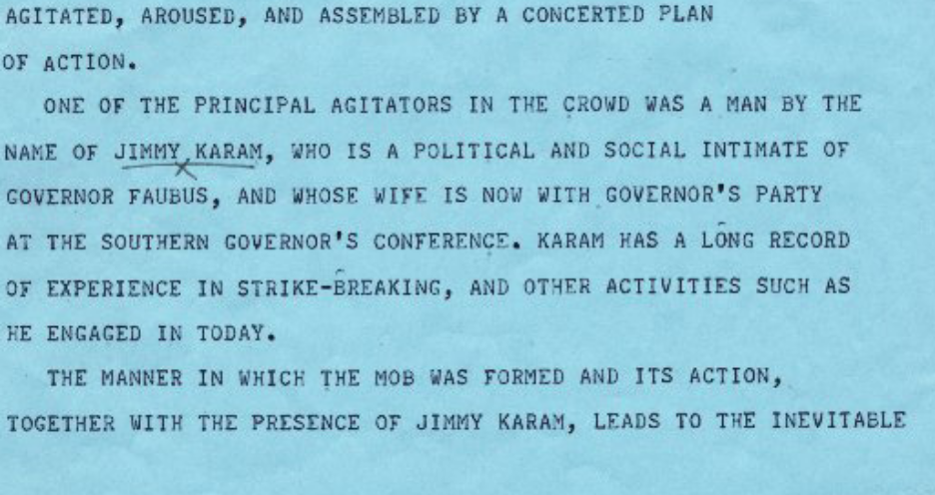

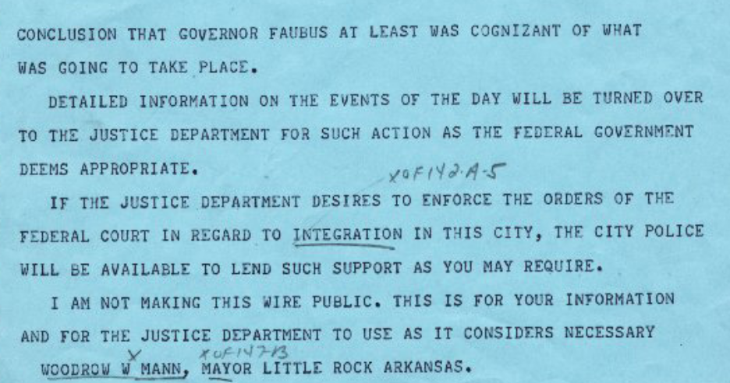

Source #12: Telegram, Woodrow Wilson Mann to President Eisenhower, September 24, 1957

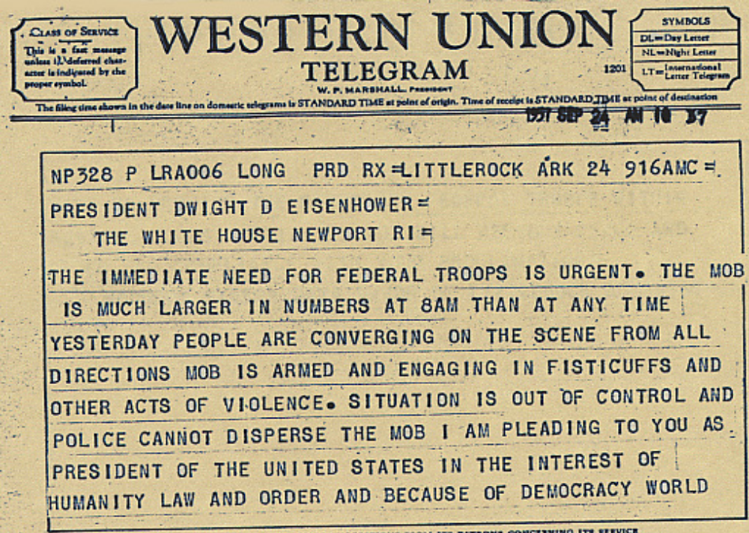

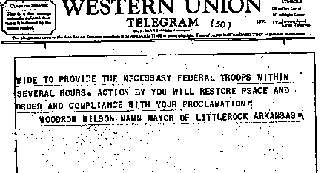

Source: Civil Rights: The Little Rock School Integration Crisis Documents. Eisenhower Presidential Library and Museum. 14 March 2011 <http://www.eisenhower.archives.gov/Research/Digital_Documents/LittleRock/littlerockdocuments.html>.

Legislating Civil Rights

Civil Rights Act of 1964
- Banned discrimination in public facilities
- Prohibited employers from discriminating on the basis of race, color, or national origin
- Allowed the federal government to cut off federal funds to projects or agencies if there was evidence that they discriminated on the basis of race, color, or national origin.
- Created the Equal Employment Opportunity Commission
- Empowered the Justice Department to bring suits against southern school districts that refused to implement the Brown decisions. So where the Brown rulings had limited impact, the Civil Rights Act came with the power of enforcement.
24th Amendment
- Outlawed poll taxes in national elections

Voting Rights Act of 1965
- Created to enforce rights under the 15th Amendment
- Outlawed literacy tests
- Appointed of Federal examiners with the power to register qualified citizens to vote.
- Required "preclearance" for any new voting practices and procedures
- Applied a nationwide prohibition of the denial or abridgment of the right to vote on account of race or color
- Directed the Attorney General to challenge the use of poll taxes in state and local elections

Teacher Background Notes

The Civil Rights Act of 1964
Ten years after Brown v. Board of Education, only two percent of black students in southern states attended desegregated schools. Without the power of enforcement, the Supreme Court's decision had limited impact. While the Court had the power to interpret the law, it was left to local school districts to implement the decision. Most southern states ignored the Court's ruling, and many local and state officials actively resisted it.
As the Civil Rights movement escalated, pressure mounted for the president and the Justice Department to assume a more active role in speeding up desegregation in public facilities, including schools.
In 1964, Congress passed the Civil Rights Act, proposed by President John F. Kennedy and signed into law by President Lyndon Johnson after Kennedy's assassination. The act banned discrimination in public facilities and prohibited employers from discriminating on the basis of race, color, or national origin. . It allowed the federal government to cut off federal funds to projects or agencies if there was evidence that they discriminated on the basis of race, color, or national origin. It created the Equal Employment Opportunity Commission (EEOC), as well as the Community Relations division of the Justice Department.
A key provision of the act with respect to school desegregation empowered the Justice Department to bring suits against southern school districts that refused to implement the Brown decisions. So where the Brown rulings had limited impact, the Civil Rights Act came with the power of enforcement. For many southern school districts, the threat of federal lawsuits and losing federal money triggered the first signs of compliance with the Court's rulings in Brown.

The Voting Rights Act of 1965
By 1965 concerted efforts to break the grip of state disfranchisement had been under way for some time, but had achieved only modest success overall and in some areas had proved almost entirely ineffectual. The murder of voting-rights activists in Philadelphia, Mississippi, gained national attention, along with numerous other acts of violence and terrorism. Finally, the unprovoked attack on March 7, 1965, by state troopers on peaceful marchers crossing the Edmund Pettus Bridge in Selma, Alabama, en route to the state capitol in Montgomery, persuaded the President and Congress to overcome Southern legislators' resistance to effective voting rights legislation. President Johnson issued a call for a strong voting rights law and hearings began soon thereafter on the bill that would become the Voting Rights Act.
Congress determined that the existing federal anti-discrimination laws were not sufficient to overcome the resistance by state officials to enforcement of the 15th Amendment. The legislative hearings showed that the Department of Justice's efforts to eliminate discriminatory election practices by litigation on a case-by-case basis had been unsuccessful in opening up the registration process; as soon as one discriminatory practice or procedure was proven to be unconstitutional and enjoined, a new one would be substituted in its place and litigation would have to commence anew.
President Johnson signed the resulting legislation into law on August 6, 1965. Section 2 of the Act, which closely followed the language of the 15th amendment, applied a nationwide prohibition against the denial or abridgment of the right to vote on the literacy tests on a nationwide basis. Among its other provisions, the Act contained special enforcement provisions targeted at those areas of the country where Congress believed the potential for discrimination to be the greatest. Under Section 5, jurisdictions covered by these special provisions could not implement any change affecting voting until the Attorney General or the United States District Court for the District of Columbia determined that the change did not have a discriminatory purpose and would not have a discriminatory effect. In addition, the Attorney General could designate a county covered by these special provisions for the appointment of a federal examiner to review the qualifications of persons who wanted to register to vote. Further, in those counties where a federal examiner was serving, the Attorney General could request that federal observers monitor activities within the county's polling place.
The Voting Rights Act had not included a provision prohibiting poll taxes, but had directed the Attorney General to challenge its use. In Harper v. Virginia State Board of Elections, 383 U.S. 663 (1966), the Supreme Court held Virginia's poll tax to be unconstitutional under the 14th Amendment. Between 1965 and 1969 the Supreme Court also issued several key decisions upholding the constitutionality of Section 5 and affirming the broad range of voting practices that required Section 5 review. As the Supreme Court put it in its 1966 decision upholding the constitutionality of the Act:
Congress had found that case-by-case litigation was inadequate to combat wide-spread and persistent discrimination in voting, because of the inordinate amount of time and energy required to overcome the obstructionist tactics invariably encountered in these lawsuits. After enduring nearly a century of systematic resistance to the Fifteenth Amendment, Congress might well decide to shift the advantage of time and inertia from the perpetrators of the evil to its victims.

The Effect of the Voting Rights Act
Soon after passage of the Voting Rights Act, federal examiners were conducting voter registration, and black voter registration began a sharp increase. The cumulative effect of the Supreme Court's decisions, Congress' enactment of voting rights legislation, and the ongoing efforts of concerned private citizens and the Department of Justice, has been to restore the right to vote guaranteed by the 14th and 15th Amendments. The Voting Rights Act itself has been called the single most effective piece of civil rights legislation ever passed by Congress.

Source: Introduction to Federal Voting Rights Law. U.S. Dept. of Justice, Civil Rights Division. 19 June 2009. 14 March 2011 <http://www.justice.gov/crt/about/vot/intro/intro.php>.

"LETTER FROM BIRMINGHAM JAIL"
April 16, 1963
Birmingham, Alabama
http://coursesa.matrix.msu.edu/~hst306/documents/letter.html

MY DEAR FELLOW CLERGYMEN:
While confined here in the Birmingham city jail, I came across your recent statement calling my present activities "unwise and untimely." . . . I want to try to answer your statements in what I hope will be patient and reasonable terms.
I think I should indicate why I am here In Birmingham, since you have been influenced by the view which argues against "outsiders coming in." I have the honor of serving as president of the Southern Christian Leadership Conference, an organization operating in every southern state, with headquarters in Atlanta, Georgia. . . . But more basically, I am in Birmingham because injustice is here. . . .
Moreover, I am cognizant of the interrelatedness of all communities and states. I cannot sit idly by in Atlanta and not be concerned about what happens in Birmingham. Injustice anywhere is a threat to justice everywhere. We are caught in an inescapable network of mutuality, tied in a single garment of destiny. Whatever affects one directly, affects all indirectly. Never again can we afford to live with the narrow, provincial "outside agitator" idea. Anyone who lives inside the United States can never be considered an outsider anywhere within its bounds.
You deplore the demonstrations taking place In Birmingham. But your statement, I am sorry to say, fails to express a similar concern for the conditions that brought about the demonstrations. . . . It is unfortunate that demonstrations are taking place in Birmingham, but it is even more unfortunate that the city's white power structure left the Negro community with no alternative.
In any nonviolent campaign there are four basic steps: collection of the facts to determine whether injustices exist; negotiation; self-purification; and direct action. We have gone through all these steps in Birmingham. There can be no gainsaying the fact that racial injustice engulfs this community. Birmingham is probably the most thoroughly segregated city in the United States. Its ugly record of brutality is widely known. Negroes have experienced grossly unjust treatment in the courts. There have been more unsolved bombings of Negro homes and churches in Birmingham than in any other city in the nation. These are the hard, brutal facts of the case. On the basis of these conditions, Negro leaders sought to negotiate with the city fathers. But the latter consistently refused to engage in good-faith negotiation. . . .
As in so many past experiences, our hopes bad been blasted, and the shadow of deep disappointment settled upon us. We had no alternative except to prepare for direct action, whereby we would present our very bodies as a means of laying our case before the conscience of the local and the national community. . . .
You may well ask: "Why direct action? Why sit-ins, marches and so forth? Isn't negotiation a better path?" You are quite right in calling, for negotiation. Indeed, this is the very purpose of direct action. Nonviolent direct action seeks to create such a crisis and foster such a tension that a community which has constantly refused to negotiate is forced to confront the issue. It seeks so to dramatize the issue that it can no longer be ignored. My citing the creation of tension as part of the work of the nonviolent-resister may sound rather shocking. But I must confess that I am not afraid of the word "tension." I have earnestly opposed violent tension, but there is a type of constructive, nonviolent tension which is necessary for growth. . . .[W]e see the need for nonviolent gadflies to create the kind of tension in society that will help men rise from the dark depths of prejudice and racism to the majestic heights of understanding and brotherhood.
The purpose of our direct-action program is to create a situation so crisis-packed that it will inevitably open the door to negotiation. I therefore concur with you in your call for negotiation. Too long has our beloved Southland been bogged down in a tragic effort to live in monologue rather than dialogue. . . .
We know through painful experience that freedom is never voluntarily given by the oppressor; it must be demanded by the oppressed. Frankly, I have yet to engage in a direct-action campaign that was "well timed" in the view of those who have not suffered unduly from the disease of segregation. For years now I have heard the word "Wait!" It rings in the ear of every Negro with piercing familiarity. This "Wait" has almost always meant 'Never." We must come to see, with one of our distinguished jurists, that "justice too long delayed is justice denied."
We have waited for more than 340 years for our constitutional and God-given rights. . . . Perhaps it is easy for those who have never felt the stinging dark of segregation to say, "Wait." But when you have seen vicious mobs lynch your mothers and fathers at will and drown your sisters and brothers at whim; when you have seen hate-filled policemen curse, kick and even kill your black brothers and sisters; when you see the vast majority of your twenty million Negro brothers smothering in an airtight cage of poverty in the midst of an affluent society; when you suddenly find your tongue twisted and your speech stammering as you seek to explain to your six-year-old daughter why she can't go to the public amusement park that has just been advertised on television, and see tears welling up in her eyes when she is told that Funtown is closed to colored children, and see ominous clouds of inferiority beginning to form in her little mental sky, and see her beginning to distort her personality by developing an unconscious bitterness toward white people; when you have to concoct an answer for a five-year-old son who is asking: "Daddy, why do white people treat colored people so mean?"; when you take a cross-county drive and find it necessary to sleep night after night in the uncomfortable corners of your automobile because no motel will accept you; when you are humiliated day in and day out by nagging signs reading "white" and "colored"; when your first name becomes "nigger," your middle name becomes "boy" (however old you are) and your last name becomes "John," and your wife and mother are never given the respected title "Mrs."; when you are harried by day and haunted by night by the fact that you are a Negro, living constantly at tiptoe stance, never quite knowing what to expect next, and are plagued with inner fears and outer resentments; . . . then you will understand why we find it difficult to wait. There comes a time when the cup of endurance runs over, and men are no longer willing to be plunged into the abyss of despair. I hope, sirs, you can understand our legitimate and unavoidable impatience.
You express a great deal of anxiety over our willingness to break laws. This is certainly a legitimate concern. Since we so diligently urge people to obey the Supreme Court's decision of 1954 outlawing segregation in the public schools, at first glance it may seem rather paradoxical for us consciously to break laws. One may won ask: "How can you advocate breaking some laws and obeying others?" The answer lies in the fact that there [are] two types of laws: just and unjust. . . . One has not only a legal but a moral responsibility to obey just laws. Conversely, one has a moral responsibility to disobey unjust laws. I would agree with St. Augustine that "an unjust law is no law at all".
Now, what is the difference between the two? How does one determine whether a law is just or unjust? A just law is a man-made code that squares with the moral law or the law of God. An unjust law is a code that is out of harmony with the moral law. To put it in the terms of St. Thomas Aquinas: An unjust law is a human law that is not rooted in eternal law and natural law. Any law that uplifts human personality is just. Any law that degrades human personality is unjust. All segregation statutes are unjust because segregation distort the soul and damages the personality. . . . Hence segregation is not only politically, economically and sociologically unsound, it is morally wrong and awful. . . . Thus it is that I can urge men to obey the 1954 decision of the Supreme Court, for it is morally right; and I can urge them to disobey segregation ordinances, for they are morally wrong.
. . . . Sometimes a law is just on its face and unjust in its application. For instance, I have been arrested on a charge of parading without a permit. Now, there is nothing wrong in having an ordinance which requires a permit for a parade. But such an ordinance becomes unjust when it is used to maintain segregation and to deny citizens the First Amendment privilege of peaceful assembly and protest.
I hope you are able to ace the distinction I am trying to point out. In no sense do I advocate evading or defying the law, as would the rabid segregationist. That would lead to anarchy. One who breaks an unjust law must do so openly, lovingly, and with a willingness to accept the penalty. I submit that an individual who breaks a law that conscience tells him is unjust and who willingly accepts the penalty of imprisonment in order to arouse the conscience of the community over its injustice, is in reality expressing the highest respect for law.
. . . . To a degree, academic freedom is a reality today because Socrates practiced civil disobedience. In our own nation, the Boston Tea Party represented a massive act of civil disobedience.
We should never forget that everything Adolf Hitler did in Germany was "legal" and everything the Hungarian freedom fighters did in Hungary was "illegal." It was "illegal" to aid and comfort a Jew in Hitler's Germany. Even so, I am sure that, had I lived in Germany at the time, I would have aided and comforted my Jewish brothers. .. . .
In your statement you assert that our actions, even though peaceful, must be condemned because they precipitate violence. But is this a logical assertion? Isn't this like condemning a robbed man because his possession of money precipitated the evil act of robbery? . . . . We must come to see that, as the federal courts have consistently affirmed, it is wrong to urge an individual to cease his efforts to gain his basic constitutional rights because the quest may precipitate violence. Society must protect the robbed and punish the robber. . . . .
Oppressed people cannot remain oppressed forever. The yearning for freedom eventually manifests itself, and that is what has happened to the American Negro. Something within has reminded him of his birthright of freedom, and something without has reminded him that it can be gained. . . . The Negro has many pent-up resentments and latent frustrations, and he must release them. So let him march; let him make prayer pilgrimages to the city hall; let him go on freedom rides-and try to understand why he must do so. If his repressed emotions are not released in nonviolent ways, they will seek expression through violence; this is not a threat but a fact of history. . . .
Before closing I feel impelled to mention one other point in your statement that has troubled me profoundly. You warmly commended the Birmingham police force for keeping "order" and "preventing violence." I doubt that you would have so warmly commended the police force if you had seen its dogs sinking their teeth into unarmed, nonviolent Negroes.. . . I cannot join you in your praise of the Birmingham police department. . . .
I wish you had commended the Negro sit-inners and demonstrators of Birmingham for their sublime courage, their willingness to suffer and their amazing discipline in the midst of great provocation. . . . They will be the James Merediths, with the noble sense of purpose that enables them to face Jeering, and hostile mobs, and with the agonizing loneliness that characterizes the life of the pioneer. They will be old, oppressed, battered Negro women, symbolized in a seventy-two-year-old woman in Montgomery, Alabama, who rose up with a sense of dignity and with her people decided not to ride segregated buses, and who responded with ungrammatical profundity to one who inquired about her weariness: "My feets is tired, but my soul is at rest." They will be the young high school and college students, the young ministers of the gospel and a host of their elders, courageously and nonviolently sitting in at lunch counters and willingly going to jail for conscience' sake. One day the South will know that when these disinherited children of God sat down at lunch counters, they were in reality standing up for what is best in the American dream and for the most sacred values in our Judaeo-Christian heritage, thereby bringing our nation back to those great wells of democracy which were dug deep by the founding fathers in their formulation of the Constitution and the Declaration of Independence.
. . . . Let us all hope that the dark clouds of racial prejudice will soon pass away and the deep fog of misunderstanding will be lifted from our fear-drenched communities, and in some not too distant tomorrow the radiant stars of love and brotherhood will shine over our great nation with all their scintillating beauty.
Yours for the cause of Peace and Brotherhood,
Martin Luther King, Jr.

Fundamental Beliefs of American Democracy

Common Good- The public or common good requires that individual citizens have the commitment and motivation to promote the welfare of the community and to work together with other members for the greater benefit of all.
Diversity- Variety in culture and ethnic background, race, lifestyle, and belief is not only permissible but desirable and beneficial in a pluralist society.
Equality- All people have the right to be treated equal (the same).
Justice- People should be treated fairly in the distribution of the benefits and burdens of society, the correction of wrongs and injuries, and in the gathering of information and making of decisions.
Liberty- The right to liberty includes personal freedom such as the freedom to think and believe. It includes political freedom: the right to participate freely in the political process, to be governed under a rule of law; the right to a free flow of information and ideas, and right of assembly. Finally, liberty encompasses economic freedom: the right to acquire, use, transfer and dispose of private property without unreasonable governmental interference; the right to seek employment wherever one pleases; and to engage in any lawful economic activity.
Life-The individual's right to life should be considered inviolable except in certain highly restricted and extreme circumstances.
Patriotism- Virtuous citizens display a devotion to their country, including devotion to the fundamental values and principles upon which it depends.
Popular Sovereignty-The citizenry is collectively the sovereign of the state and holds ultimate authority over public officials and their policies.
The Pursuit of Happiness- It is the right of citizens in the American constitutional democracy to attempt to attain--to "pursue"--happiness in their own way, so long as they do not infringe upon rights of others.
Truth- Citizens can legitimately demand that truth-telling and full disclosure by government be the rule, since trust in the veracity of government constitutes an essential element of the bond between governors and governed.
Constitutional Principles
Rule of Law-Both government and the governed should be subject to the law.
Separation of Powers- Legislative, executive, and judicial powers should be exercised by different institutions in order to maintain the limitations placed upon them.
Representative Government- The republican form of government established under the Constitution is one in which citizens elect others to represent their interests.
Checks and Balances- The powers given to the different branches of government should be balanced, that is roughly equal, so that no branch can completely dominate the others. Branches of government are also given powers to check the power of other branches.
Individual Rights- Fundamental to American constitutional democracy is the belief that individuals have certain basic rights that are not created by government but which government should protect. These are the right to life, liberty, economic freedom, and the "pursuit of happiness." It is the purpose of government to protect these rights, and it may not place unfair or unreasonable restraints on their exercise. Many of these rights are enumerated in the Bill of Rights.
Freedom of Religion- There shall be full freedom of conscience for people of all faiths or none. Religious liberty includes the right to freely practice any religion or no religion without governmental coercion or control.
Federalism- Power is shared between two sets of governmental institutions, those of the states and those of the central or federal authorities, as stipulated by the Constitution.
Civilian Control of the Military- Civilian authority controls the military to preserve constitutional government.
Declaration of Independence
When in the course of human events, it becomes necessary for one people to dissolve the political bands which have connected them with another, and to assume among the powers of the earth, the separate and equal station to which the laws of nature and of nature's God entitle them, a decent respect to the opinions of mankind requires that they should declare the causes which impel them to the separation.
We hold these truths to be self-evident:
That all men are created equal; that they are endowed by their Creator with certain unalienable rights; that among these are life, liberty, and the pursuit of happiness; that, to secure these rights, governments are instituted among men, deriving their just powers from the consent of the governed; that whenever any form of government becomes destructive of these ends, it is the right of the people to alter or to abolish it, and to institute new government, laying its foundation on such principles, and organizing its powers in such form, as to them shall seem most likely to effect their safety and happiness. Prudence, indeed, will dictate that governments long established should not be changed for light and transient causes; and accordingly all experience hath shown that mankind are more disposed to suffer, while evils are sufferable than to right themselves by abolishing the forms to which they are accustomed. But when a long train of abuses and usurpations, pursuing invariably the same object, evinces a design to reduce them under absolute despotism, it is their right, it is their duty, to throw off such government, and to provide new guards for their future security. Such has been the patient sufferance of these colonies; and such is now the necessity which constrains them to alter their former systems of government. The history of the present King of Great Britain is a history of repeated injuries and usurpations, all having in direct object the establishment of an absolute tyranny over these states. To prove this, let facts be submitted to a candid world.
He has refused his assent to laws, the most wholesome and necessary for the public good.
He has forbidden his governors to pass laws of immediate and pressing importance, unless suspended in their operation till his assent should be obtained; and, when so suspended, he has utterly neglected to attend to them.
He has refused to pass other laws for the accommodation of large districts of people, unless those people would relinquish the right of representation in the legislature, a right inestimable to them, and formidable to tyrants only.
He has called together legislative bodies at places unusual uncomfortable, and distant from the depository of their public records, for the sole purpose of fatiguing them into compliance with his measures.
He has dissolved representative houses repeatedly, for opposing, with manly firmness, his invasions on the rights of the people.
He has refused for a long time, after such dissolutions, to cause others to be elected; whereby the legislative powers, incapable of annihilation, have returned to the people at large for their exercise; the state remaining, in the mean time, exposed to all the dangers of invasions from without and convulsions within.
He has endeavored to prevent the population of these states; for that purpose obstructing the laws for naturalization of foreigners; refusing to pass others to encourage their migration hither, and raising the conditions of new appropriations of lands.
He has obstructed the administration of justice, by refusing his assent to laws for establishing judiciary powers.
He has made judges dependent on his will alone, for the tenure of their offices, and the amount and payment of their salaries.
He has erected a multitude of new offices, and sent hither swarms of officers to harass our people and eat out their substance.
He has kept among us, in times of peace, standing armies, without the consent of our legislatures.
He has affected to render the military independent of, and superior to, the civil power.
He has combined with others to subject us to a jurisdiction foreign to our Constitution and unacknowledged by our laws, giving his assent to their acts of pretended legislation:
For quartering large bodies of armed troops among us;
For protecting them, by a mock trial, from punishment for any murders which they should commit on the inhabitants of these states;
For cutting off our trade with all parts of the world;
For imposing taxes on us without our consent;
For depriving us, in many cases, of the benefits of trial by jury;
For transporting us beyond seas, to be tried for pretended offenses;
For abolishing the free system of English laws in a neighboring province, establishing therein an arbitrary government, and enlarging its boundaries, so as to render it at once an example and fit instrument for introducing the same absolute rule into these colonies;
For taking away our charters, abolishing our most valuable laws, and altering fundamentally the forms of our governments;
For suspending our own legislatures, and declaring themselves invested with power to legislate for us in all cases whatsoever.
He has abdicated government here, by declaring us out of his protection and waging war against us.
He has plundered our seas, ravaged our coasts, burned our towns, and destroyed the lives of our people.
He is at this time transporting large armies of foreign mercenaries to complete the works of death, desolation, and tyranny already begun with circumstances of cruelty and perfidy scarcely paralleled in the most barbarous ages, and totally unworthy the head of a civilized nation.
He has constrained our fellow-citizens, taken captive on the high seas, to bear arms against their country, to become the executioners of their friends and brethren, or to fall themselves by their hands.
He has excited domestic insurrection among us, and has endeavored to bring on the inhabitants of our frontiers the merciless Indian savages, whose known rule of warfare is an undistinguished destruction of all ages, sexes, and conditions.
In every stage of these oppressions we have petitioned for redress in the most humble terms; our repeated petitions have been answered only by repeated injury. A prince, whose character is thus marked by every act which may define a tyrant, is unfit to be the ruler of a free people.
Nor have we been wanting in our attentions to our British brethren. We have warned them, from time to time, of attempts by their legislature to extend an unwarrantable jurisdiction over us. We have reminded them of the circumstances of our emigration and settlement here. We have appealed to their native justice and magnanimity; and we have conjured them, by the ties of our common kindred, to disavow these usurpations which would inevitably interrupt our connections and correspondence. They too, have been deaf to the voice of justice and of consanguinity. We must, therefore, acquiesce in the necessity which denounces our separation, and hold them as we hold the rest of mankind, enemies in war, in peace friends.
We, therefore, the representatives of the United States of America, in General Congress assembled, appealing to the Supreme Judge of the world for the rectitude of our intentions, do, in the name and by the authority of the good people of these colonies solemnly publish and declare, That these United Colonies are, and of right ought to be, FREE AND INDEPENDENT STATES; that they are absolved from all allegiance to the British crown and that all political connection between them and the state of Great Britain is, and ought to be, totally dissolved; and that, as free and independent states, they have full power to levy war, conclude peace, contract alliances, establish commerce, and do all other acts and things which independent states may of right do. And for the support of this declaration, with a firm reliance on the protection of Divine Providence, we mutually pledge to each other our lives, our fortunes, and our sacred honor.

Declaration of Independence. The Avalon Project. Yale Law School. 14 March 2011 <http://avalon.law.yale.edu/18th_century/declare.asp>.

The Gettysburg Address

"Fourscore and seven years ago our fathers brought forth on this continent a new nation, conceived in liberty and dedicated to the proposition that all men are created equal. Now we are engaged in a great civil war, testing whether that nation or any nation so conceived and so dedicated can long endure. We are met on a great battlefield of that war. We have come to dedicate a portion of that field as a final resting-place for those who here gave their lives that that nation might live. It is altogether fitting and proper that we should do this. But in a larger sense, we cannot dedicate, we cannot consecrate, we cannot hallow this ground. The brave men, living and dead who struggled here have consecrated it far above our poor power to add or detract. The world will little note nor long remember what we say here, but it can never forget what they did here. It is for us the living rather to be dedicated here to the unfinished work which they who fought here have thus far so nobly advanced. It is rather for us to be here dedicated to the great task remaining before us--that from these honored dead we take increased devotion to that cause for which they gave the last full measure of devotion--that we here highly resolve that these dead shall not have died in vain, that this nation under God shall have a new birth of freedom, and that government of the people, by the people, for the people shall not perish from the earth."

The Gettysburg Address. The Avalon Project. Yale Law School. 14 March 2011 <http://avalon.law.yale.edu/19th_century/gettyb.asp>.

I Have A Dream
I am happy to join with you today in what will go down in history as the greatest demonstration for freedom in the history of our nation.
Five score years ago, a great American, in whose symbolic shadow we stand today, signed the Emancipation Proclamation. This momentous decree came as a great beacon light of hope to millions of Negro slaves who had been seared in the flames of withering injustice. It came as a joyous daybreak to end the long night of their captivity.
But one hundred years later, the Negro still is not free. One hundred years later, the life of the Negro is still sadly crippled by the manacles of segregation and the chains of discrimination. One hundred years later, the Negro lives on a lonely island of poverty in the midst of a vast ocean of material prosperity. One hundred years later, the Negro is still languished in the corners of American society and finds himself an exile in his own land. And so we've come here today to dramatize a shameful condition.
In a sense we've come to our nation's capital to cash a check. When the architects of our republic wrote the magnificent words of the Constitution and the Declaration of Independence, they were signing a promissory note to which every American was to fall heir. This note was a promise that all men, yes, black men as well as white men, would be guaranteed the "unalienable Rights" of "Life, Liberty and the pursuit of Happiness." It is obvious today that America has defaulted on this promissory note, insofar as her citizens of color are concerned. Instead of honoring this sacred obligation, America has given the Negro people a bad check, a check which has come back marked "insufficient funds."
But we refuse to believe that the bank of justice is bankrupt. We refuse to believe that there are insufficient funds in the great vaults of opportunity of this nation. And so, we've come to cash this check, a check that will give us upon demand the riches of freedom and the security of justice.
We have also come to this hallowed spot to remind America of the fierce urgency of Now. This is no time to engage in the luxury of cooling off or to take the tranquilizing drug of gradualism. Now is the time to make real the promises of democracy. Now is the time to rise from the dark and desolate valley of segregation to the sunlit path of racial justice. Now is the time to lift our nation from the quicksands of racial injustice to the solid rock of brotherhood. Now is the time to make justice a reality for all of God's children.
It would be fatal for the nation to overlook the urgency of the moment. This sweltering summer of the Negro's legitimate discontent will not pass until there is an invigorating autumn of freedom and equality. Nineteen sixty-three is not an end, but a beginning. And those who hope that the Negro needed to blow off steam and will now be content will have a rude awakening if the nation returns to business as usual. And there will be neither rest nor tranquility in America until the Negro is granted his citizenship rights. The whirlwinds of revolt will continue to shake the foundations of our nation until the bright day of justice emerges.
But there is something that I must say to my people, who stand on the warm threshold which leads into the palace of justice: In the process of gaining our rightful place, we must not be guilty of wrongful deeds. Let us not seek to satisfy our thirst for freedom by drinking from the cup of bitterness and hatred. We must forever conduct our struggle on the high plane of dignity and discipline. We must not allow our creative protest to degenerate into physical violence. Again and again, we must rise to the majestic heights of meeting physical force with soul force.
The marvelous new militancy which has engulfed the Negro community must not lead us to a distrust of all white people, for many of our white brothers, as evidenced by their presence here today, have come to realize that their destiny is tied up with our destiny. And they have come to realize that their freedom is inextricably bound to our freedom.
We cannot walk alone.
And as we walk, we must make the pledge that we shall always march ahead.
We cannot turn back.
There are those who are asking the devotees of civil rights, "When will you be satisfied?" We can never be satisfied as long as the Negro is the victim of the unspeakable horrors of police brutality. We can never be satisfied as long as our bodies, heavy with the fatigue of travel, cannot gain lodging in the motels of the highways and the hotels of the cities. We cannot be satisfied as long as the negro's basic mobility is from a smaller ghetto to a larger one. We can never be satisfied as long as our children are stripped of their self-hood and robbed of their dignity by signs stating: "For Whites Only." We cannot be satisfied as long as a Negro in Mississippi cannot vote and a Negro in New York believes he has nothing for which to vote. No, no, we are not satisfied, and we will not be satisfied until "justice rolls down like waters, and righteousness like a mighty stream."¹
I am not unmindful that some of you have come here out of great trials and tribulations. Some of you have come fresh from narrow jail cells. And some of you have come from areas where your quest -- quest for freedom left you battered by the storms of persecution and staggered by the winds of police brutality. You have been the veterans of creative suffering. Continue to work with the faith that unearned suffering is redemptive. Go back to Mississippi, go back to Alabama, go back to South Carolina, go back to Georgia, go back to Louisiana, go back to the slums and ghettos of our northern cities, knowing that somehow this situation can and will be changed.
Let us not wallow in the valley of despair, I say to you today, my friends.
And so even though we face the difficulties of today and tomorrow, I still have a dream. It is a dream deeply rooted in the American dream.
I have a dream that one day this nation will rise up and live out the true meaning of its creed: "We hold these truths to be self-evident, that all men are created equal."
I have a dream that one day on the red hills of Georgia, the sons of former slaves and the sons of former slave owners will be able to sit down together at the table of brotherhood.
I have a dream that one day even the state of Mississippi, a state sweltering with the heat of injustice, sweltering with the heat of oppression, will be transformed into an oasis of freedom and justice.
I have a dream that my four little children will one day live in a nation where they will not be judged by the color of their skin but by the content of their character.
I have a dream today!
I have a dream that one day, down in Alabama, with its vicious racists, with its governor having his lips dripping with the words of "interposition" and "nullification" -- one day right there in Alabama little black boys and black girls will be able to join hands with little white boys and white girls as sisters and brothers.
I have a dream today!
I have a dream that one day every valley shall be exalted, and every hill and mountain shall be made low, the rough places will be made plain, and the crooked places will be made straight; "and the glory of the Lord shall be revealed and all flesh shall see it together."²
This is our hope, and this is the faith that I go back to the South with.
With this faith, we will be able to hew out of the mountain of despair a stone of hope. With this faith, we will be able to transform the jangling discords of our nation into a beautiful symphony of brotherhood. With this faith, we will be able to work together, to pray together, to struggle together, to go to jail together, to stand up for freedom together, knowing that we will be free one day.
And this will be the day -- this will be the day when all of God's children will be able to sing with new meaning:
My country 'tis of thee, sweet land of liberty, of thee I sing.
Land where my fathers died, land of the Pilgrim's pride,
From every mountainside, let freedom ring!
And if America is to be a great nation, this must become true.
And so let freedom ring from the prodigious hilltops of New Hampshire.
Let freedom ring from the mighty mountains of New York.
Let freedom ring from the heightening Alleghenies of Pennsylvania.
Let freedom ring from the snow-capped Rockies of Colorado.
Let freedom ring from the curvaceous slopes of California.
But not only that:
Let freedom ring from Stone Mountain of Georgia.
Let freedom ring from Lookout Mountain of Tennessee.
Let freedom ring from every hill and molehill of Mississippi.
From every mountainside, let freedom ring.
And when this happens, when we allow freedom ring, when we let it ring from every village and every hamlet, from every state and every city, we will be able to speed up that day when all of God's children, black men and white men, Jews and Gentiles, Protestants and Catholics, will be able to join hands and sing in the words of the old Negro spiritual:
Free at last! Free at last!
Thank God Almighty, we are free at last!
March on Washington Speech: I Have a Dream. The Avalon Project. Yale Law School. 14 March 2011 <http://avalon.law.yale.edu/20th_century/mlk01.asp>.

The Declaration of Sentiments
When, in the course of human events, it becomes necessary for one portion of the family of man to assume among the people of the earth a position different from that which they have hitherto occupied, but one to which the laws of nature and of nature's God entitle them, a decent respect to the opinions of mankind requires that they should declare the causes that impel them to such a course.
We hold these truths to be self-evident: that all men and women are created equal; that they are endowed by their Creator with certain inalienable rights; that among these are life, liberty, and the pursuit of happiness; that to secure these rights governments are instituted, deriving their just powers from the consent of the governed. Whenever any form of government becomes destructive of these ends, it is the right of those who suffer from it to refuse allegiance to it, and to insist upon the institution of a new government, laying its foundation on such principles, and organizing its powers in such form, as to them shall seem most likely to effect their safety and happiness. Prudence, indeed, will dictate that governments long established should not be changed for light and transient causes; and accordingly all experience hath shown that mankind are more disposed to suffer. while evils are sufferable, than to right themselves by abolishing the forms to which they are accustomed. But when a long train of abuses and usurpations, pursuing invariably the same object, evinces a design to reduce them under absolute despotism, it is their duty to throw off such government, and to provide new guards for their future security. Such has been the patient sufferance of the women under this government, and such is now the necessity which constrains them to demand the equal station to which they are entitled. The history of mankind is a history of repeated injuries and usurpations on the part of man toward woman, having in direct object the establishment of an absolute tyranny over her. To prove this, let facts be submitted to a candid world.
The history of mankind is a history of repeated injuries and usurpations on the part of man toward woman, having in direct object the establishment of an absolute tyranny over her. To prove this, let facts be submitted to a candid world.
He has never permitted her to exercise her inalienable right to the elective franchise.
He has compelled her to submit to laws, in the formation of which she had no voice.
He has withheld from her rights which are given to the most ignorant and degraded men--both natives and foreigners.
Having deprived her of this first right of a citizen, the elective franchise, thereby leaving her without representation in the halls of legislation, he has oppressed her on all sides.
He has made her, if married, in the eye of the law, civilly dead.
He has taken from her all right in property, even to the wages she earns.
He has made her, morally, an irresponsible being, as she can commit many crimes with impunity, provided they be done in the presence of her husband. In the covenant of marriage, she is compelled to promise obedience to her husband, he becoming, to all intents and purposes, her master--the law giving him power to deprive her of her liberty, and to administer chastisement.
He has so framed the laws of divorce, as to what shall be the proper causes, and in case of separation, to whom the guardianship of the children shall be given, as to be wholly regardless of the happiness of women--the law, in all cases, going upon a flase supposition of the supremacy of man, and giving all power into his hands.
After depriving her of all rights as a married woman, if single, and the owner of property, he has taxed her to support a government which recognizes her only when her property can be made profitable to it.
He has monopolized nearly all the profitable employments, and from those she is permitted to follow, she receives but a scanty remuneration. He closes against her all the avenues to wealth and distinction which he considers most homorable to himself. As a teacher of theoloy, medicine, or law, she is not known.
He has denied her the facilities for obtaining a thorough education, all colleges being closed against her.
He allows her in church, as well as state, but a subordinate position, claiming apostolic authority for her exclusion from the ministry, and, with some exceptions, from any public participation in the affairs of the church.
He has created a false public sentiment by giving to the world a different code of morals for men and women, by which moral delinquencies which exclude women from society, are not only tolerated, but deemed of little account in man.
He has usurped the prerogative of Jehovah himself, claiming it as his right to assign for her a sphere of action, when that belongs to her conscience and to her God.
He has endeavored, in every way that he could, to destroy her conficence in her own powers, to lessen her self-respect, and to make her willing to lead a dependent and abject life.
Now, in view of this entire disfranchisement of one-half the people of this country, their social and religious degradation--in view of the unjust laws above mentioned, and because women do feel themselves aggrieved, oppressed, and fraudulently deprived of their most sacred rights, we insist that they have immediate admission to all the rights and privileges which belong to them as citizens of the United States.

Modern History Sourcebook: The Declaration of Sentiments, Seneca Falls Conference, 1848. 12 July 2010 <http://www.fordham.edu/halsall/mod/senecafalls.html>. I never know whether typos should be corrected in primary documents like this or not.

Understanding Continuity and Change

Students sometimes misunderstand history as a list of events. Once they start to understand history as a complex mix of continuity and change, they reach a fundamentally different sense of the past.
There were lots of things going on at any one time in the past. Some changed rapidly while others remained relatively continuous. For instance, the everyday use of the Internet in the 1990s, for instance, saw profound change in many aspects of trade, social communication, and information seeking, but not much change in how schools taught students. Looking at schooling, someone might argue that nothing changed; the school day remained the same, students were separated by grade levels, and the school year was designed around the harvest calendar. However, a closer look reveals that the way students obtained information and communicated significantly changed during this period.
One of the keys to continuity and change is looking for change where common sense suggests that there has been none and looking for continuities where we assumed that there was change. Judgments of continuity and change can be made on the basis of comparisons between some point in the past and the present, or between two points in the past, such as before and after the explosion of the Internet. We evaluate change over time using the ideas of progress and decline.

Adapted from: “Continuity and Change.” Benchmarks of Historical Thinking. Centre for the Study of Historical Consciousness. Canada. 14 March 2011 <http://www.histori.ca/benchmarks/concept/continuity-and-change>.

